Final

SWIMPTKIN 2024 FOREST MANAGEMENT PROJECT

ENVIRONMENTAL ASSESSMENT
Proposed Action: The Bureau of Indian Affairs and the Confederated Tribes of the Colville Indian Reservation propose the harvest of approximately 8.3 million board feet (MMBF) of timber from 1,522 acres of tribal land in the Omak/Nespelem District of the Colville Reservation.
Prepared by:
The Bureau of Indian Affairs and the Colville Confederated Tribes of the Colville Indian Reservation
Official Decision Maker: Randy Friedlander, Superintendent, Colville Agency, BIA
For further information: Chasity Swan
IRMP Coordinator
PO BOX 150 Nespelem, WA 99155
(509) 722-7656
Chasity.Swan.bia@colvilletribes.com

March 26, 2024
BIA FILE NO: EA-24-13

Table of Contents
1.0 Purpose and Need 3
1.1 Introduction 3
1.2 Purpose and Need for Action 3
1.3 Objectives 4
1.4 Compliance with Other Codes and Regulations 6
1.5 Determination 6
1.6 Public Involvement 6
2.0 Alternatives Considered 7
2.1 General Discussion: Alternative Design 7
2.2 Alternative A: No Action 7
2.3 Alternative B: Proposed Action 8
3.0 Affected Environment 12
3.1 Forestry 12
3.2 Soils 13
3.3 Hydrology 14
3.4 Fish and Wildlife 16
3.5 Cultural Resources 19
3.6 Range Management 22
3.7 Air Quality 22
3.8 Fuels/Fire Management 24
4.0 Environmental Consequences 24
4.1 Forestry 25
4.2 Soils 26
4.3 Hydrology 28
4.4 Fish and Wildlife 41
4.5 Cultural Resources 45
4.6 Range Management 46
4.7 Air Quality 48
4.8 Cumulative Impacts 48
4.9 Social and Economic Impacts 48
5.0 List of Preparers 49
6.0 Literature Cited 49
7.0 Appendices 52
7.1 Appendix A: Activity Table and Map 52
7.2 Appendix B: Consultation 55
7.3 Appendix C: Preliminary Transportation Analysis 61
7.4 Appendix D: Army Corp of Engineers BMPs 64
7.5 Appendix E: Fish and Wildlife Proposed Wildlife Buffers and Road Closures 66
7.6 Appendix F: CTCR Holistic Goal and Desired Future Conditions 67
7.7 Appendix G: Fire Regimes and Condition Class 69

1.0 Purpose and Need

1.1 Introduction
The following Environmental Assessment (EA) analyzes the impacts of Swimptkin 2024 Forest Management Project. The Bureau of Indian Affairs (BIA) and the Confederated Tribes of the Colville Indian Reservation (CTCR) propose the harvest of approximately 8.3 MMBF of timber from approximately 1,522 acres of Tribal land in the Omak/Nespelem District (OND) of the Colville Indian Reservation in Okanogan County, Washington State. This harvest would require about 1.7 miles of road construction and about 26.5 miles of road reconstruction.
The federal action (40 CFR 1508.18) is the BIA approval of the Swimptkin 2024 Forest Management Project, which triggers BIA’s National Environmental Protection Act (NEPA) compliance review of the project 42 USC § 4321- 4347) and associated regulations found in 40 CFR 1500-1508 (as amended) and 43 CFR 46.
This EA contains the minimum requirements found in 43 CFR 46.310 (a) including brief discussions of the following:
- The proposal;
- The purpose and need for the proposal;
- The environmental impacts of the proposed action;
- The environmental impacts of the alternatives considered; and
- A list of agencies and persons consulted.
1.2 Purpose and Need for Action
The purpose of the action is to be able to implement the activities under the federal action to meet the primary need meeting the goals outline in the CTCR 2015 Integrated Resource Management Plan (IRMP). The CTCR utilized consensus building process (Chadwick 1995) for gathering input from the Tribal Membership to develop the Tribes Holistic Goal and Desired Future conditions enacted by the Colville Business Council by Resolution 1996-23 (Appendix C). The CTCR IRMP has set an annual harvest level of 77.1 million board feet (MMBF)(CTCR 2015). This project would contribute toward reaching this target volume. The IRMP sets goals and objectives to manage the Reservation forestlands with management practices that integrate protections for water quality and quantity, fish and wildlife, soils, vegetation, cultural resources, recreation and scenic beauty. Forest Management also allows the tribe to maintain a sustainable forest products industry to provide revenue for the Colville Tribes and economic benefits for the people of the Reservation.
The Swimptkin Project Area contains stands of timber that present a high risk of sustaining losses to several forest insect and disease agents. Harvest of the stands with the most hazard for these agents – either by: (1) removing the damaged & most susceptible trees or (2) by regenerating the stand to trees of the most well adapted species, or (3) by some combination of 1 or 2 – would reduce the risk of mortality loss.
A more detailed discussion of the forest health issues on the Colville Reservation and the need for treatment can be review in the 2023 Forest Management Plan (FMP). Environmental impacts from the management of CTCR Natural Resources under the IRMP and the FMP have been analyzed in the Final Programmatic Environmental Impact Statement (FEIS) (CAR 2018).
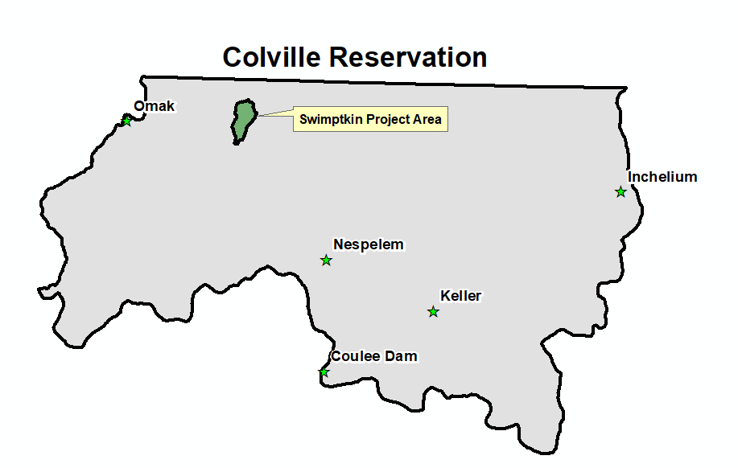
Figure 1. Swimptkin Project Area on the Colville Indian Reservation.
1.3 Objectives
To provide income for the Colville Tribes.
Indicator:
- Estimated stumpage produced by each alternative.
- To provide employment for the tribal membership.
- To provide profit for tribally owned businesses.
Indicator:
  - Estimated volume of timber harvested per alternative.
Soil Resource Objectives
- To avoid causing detrimental soils conditions on more than 25% of the treatment (logged) area.
Indicators:
- Displacement: movement or removal of topsoil.
- Compaction: topsoil is noticeably compressed or flattened, decreasing several inches in depth in contrast to nearby undisturbed soils of similar character.
- Fire damage: most of the topsoil is consumed and the top layer of mineral soil has changed color.
- Rutting of soil in the bottom of swales and draws.
Hydrology Objectives
1. To minimize erosion and sediment delivery to surface waters and prevent streambank/wetland disturbance.
Indicators:
- Road construction and use.
- Road density by watershed.
- Road construction/use within 200ft of surface water.
- Harvest within 200ft of surface water.
- Harvest on vulnerable soils.
Fish and Wildlife Objectives
- To maintain and restore critical forest structure; old growth forests, deciduous stands, wetlands, large woody debris, etc.
Indicator:
  - Wetland and stream adjacency acres.
- To reduce alterations to fish and wildlife habitat in order to sustain viable populations and communities through maintained thermal, forage and travel cover and reduction of habitat fragmentation.
Indicators:
- Block size and adjacency, acres.
- Road density, mi/mi².
- Miles of new road construction.
- To maintain or increase the quantity and quality of habitat necessary to sustain and restore fish populations through high quality habitat and water.
Indicators:
- Miles of new road construction.
- Density of stream crossings (new, existing, removed).
- Miles of stream adjacency.
1.4 Compliance with Other Codes and Regulations

This project is designed to be compliant with CTCR Forest Practices Code (208), CTC 4-9: Hydraulic Project Permitting, 4-10: Water Resources Use and Permitting, the Endangered Species Act, Clean Water Act, National Environmental Policy Act, Tribal Forest Protection Act, National Indian Forest Resources and Management Act, National Historic Preservation Act, Clean Air Act and other applicable Tribal and Federal Regulations.

1.5 Determination
The Colville Agency BIA Superintendent with the concurrence of the Colville Business Council (CBC) would determine which alternative is selected for implementation.
- To take no action (Alternative A).
- To approve the proposed action (Alternative B).
- To direct an additional alternative be created.
The BIA Superintendent would also determine whether the environmental consequences are significant and prepare either a Finding of No Significant Impact (FONSI) or determine that Environmental Impact Statement (EIS) would be required.

1.6 Public Involvement
In the process updating of the IRMP which provides goals and objectives to manage the Tribes’ natural resources a Colville Reservation Community survey was conducted to document the priorities, preferences and concerns regarding the management of the Tribes’ natural resources (Center for Applied Research [CAR] 2015). A total of 1,026 individuals participated. Respondents indicated the forests provide essential revenue source (47%) and jobs (52%) for the tribal membership and community. The strongest response on forest management (54%) was for forest-wide thinning of insect and fire prone tree stands and to treat forest health issues. Many community meetings were held to help shape the CTCR management strategy during the 2001 and 2015 IRMP planning processes.
The Swimptkin Forest Management Project was presented to the 3P Team in March of 2023. The 3P Team and public also had a field tour of the project area in June of 2023. This project is a part of that 15-year plan for Forest Resource Management on the Reservation (CTCR 2015).
2.0 Alternatives Considered

2.1 General Discussion: Alternative Design

The National Environmental Policy Act (NEPA) and the Council on Environmental Quality (CEQ), the Department of the Interior (DOI) and the BIA have developed regulations that require that a reasonable range of alternatives be considered in NEPA documentation, including the “Proposed Action” and “No Action” alternatives.
For this project, Alternative A (No Action) is included to fulfill the requirements of NEPA and to provide baseline values by which to measure the effects of other alternatives. For the purposes of this document, “no action” means that no harvest or other resource manipulation would occur if this alternative were adopted.
Alternative B (the Proposed Action) was constructed to fulfill the purpose and need. That is, Alternative B was designed to:
- Capture the value of fire damaged timber
- Provide stumpage income for the Tribal Government of the Colville Tribes,
- Provide employment for tribal members,
- Provide opportunity for profit for tribally owned businesses,
- Improve general forest health,
- Expand forest regulation.
All alternatives are designed to meet all legal and procedural requirements to which the CTCR and the BIA must adhere.

2.2 Alternative A: No Action
The “No Action Alternative” includes the BIA not approving the Swimptkin 2024 Project at this time and/or the BIA and Tribe not implementing activities under the project. Under this alternative no timber harvest, road reconstruction, or other manipulation of resources would take place.

2.3 Alternative B: Proposed Action
The Proposed Action Alternative includes the BIA approving the Swimptkin 2024 Forest Management Project and the BIA and CTCR implementing the activities under the proposal. This Alternative does meet the Purpose and Need of the project. This alternative was proposed by OND Foresters to meet forest health needs, and provide volume for the Annual Allowable Cut (AAC) of 77.1 MMBF outlined in the IRMP (2015).
Timber Harvest of roughly 8.3 MMBF from 1,522 acres of timber harvest blocks. Non timber harvest activities included in this Proposal are: 172 acres of Pre-Commercial Thin (PCT), and 2,061.6 acres of prescribed underburn.
- Let it be noted that individual block prescriptions given in this document are given in good faith and are appropriate for data collected and field review notes up to this point. However, prescriptions may be adjusted when entire block is evaluated through the timber cruise and marked for harvest.
- Pre-Commercial Thinning would be completed with traditional chainsaw thinning or a piece of heavy equipment such as an excavator may also be used; to achieve the desired spacing of residual stand.
Table 1. Prescription Summary for Alternative B.
Prescription- Non-Commercial Harvest | Acres
Pre-commercial Thin (PCT) | 172
Tree Planting- Artificial Regeneration | 95
Prescription- Commercial Harvest | Acres
Regeneration with Reserves (RRT) | 95
Seed Tree / Overstory Removal (ST/OR) | 254
Seed Tree (ST) | 321
Shelterwood (SW) | 72
Sanitation (SANI) | 224
Improvement Cut (IC) | 441
Overstory Removal (OR) | 115
Total Commercial Harvest | 1,522
Table 2. Alternative B harvest systems.
Logging Method | Acres
Tractor | 1,203.8
Tether | 318.2
Total | 1,522
Table 3. Alternative B road construction and reconstruction.
Roads | Abbreviation | Miles
New Construction | Proposed | 1.7
Reconstruction | Reconstruct | 26.5
Road Closure Plan
All newly constructed roads would be closed following post-harvest activities in accordance with forest practices 4-7-60 2(E).
Other Project Design Features
There are many other project design features that are included in this alternative. These are included to help protect other resources such as fish and wildlife, and riparian areas. Some of these design features are outlined below. These design features would help mitigate most of the issues and concerns raised by Fish and Wildlife, Soils and Hydrology. These design features would make the project meet the standards of the IRMP and Forest Practices Code and help to mitigate some of the potential negative impacts of the project.
- Habitat patches would be left in the large units to break up the “continuity” on the landscape and provide refuge for wildlife.
- Scattered over-story trees would be left on all units to provide a future source of snags and down woody debris.
- Streams and wetlands would be buffered as required by the current 208 guidelines.
- A combination of cable logging and ground-based systems would be used, depending on steepness of the units and road placement.
- Summer and winter seasonal restrictions would be placed on units to protect the sensitive ash cap soils from erosion. Summer would be dry soil conditions; winter restrictions would require frozen ground and/or 2 feet of snow.
- Archeological sites would be buffered and protected from logging damage.
- Corridors would be in place on the landscape to allow wildlife to travel across the project area while being secure.
- Continued monitoring for specific wildlife species would occur and operational adjustments can be made if needed.
- Skid trails would be spaced at least 100 feet to reduce soil compaction and displacement.
When timber harvest takes place, Best Management Practices (BMP’s) outlined in the Colville Confederated Tribes Forest Practices Handbook (208 Handbook), dated 2023, would be employed. Timber contract compliance by the Timber Sale Officer (TSO) would be the foremost method ensuring that the BMP’s are followed and implemented. Proper maintenance of roads and skid trails after logging operations would be implemented to reduce erosion. Designated skid trails and cable logging would help reduce impacts to the soil resources. Slash treatments, on the ground and at the landings, would be either lop & scattered, slash, excavator piled & burned, prescribed burned or left on site. The continual management of the stands including monitoring from initial stand development to the maturity of the stand would be completed by various forestry staff such as Silviculturists, Timber Sale Officers, and forest development staff. The monitoring would ensure the individual stands are going down the anticipated pathway to the desired future conditions.
Culverts would be replaced at certain locations depending on the necessity which would be determined by the TSO’s, District Officer, the Road Engineer, or ETD NPS Management Coordinator. Also, new culverts would be installed to allow the continual flow of water to remain in the same established channel and accommodate the estimated discharge of a 100-year flood event. Water sources would be identified on the FPA/HPA application as potential sites to obtain water for road watering, dependent on approval from the Water Administrator. Calcium chloride may be used on sections of road as an alternative to road watering.
Riparian Management Zones (RMZ) would be identified in the planning process using stream classification maps and determined by Presales Department personnel during block boundary layout. RMZ buffers would follow requirements of the Forest Practices Code (CTC 4-7), dated 2023. During implementation of road construction activities and logging operations, some trees may need to be harvested, if they present a safety hazard.

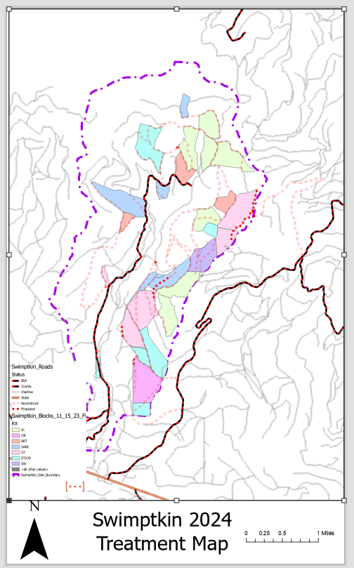
Figure 2. Swimptkin 2024 Project Area Harvest Blocks.
3.0 Affected Environment

3.1 Forestry
Affected Environment
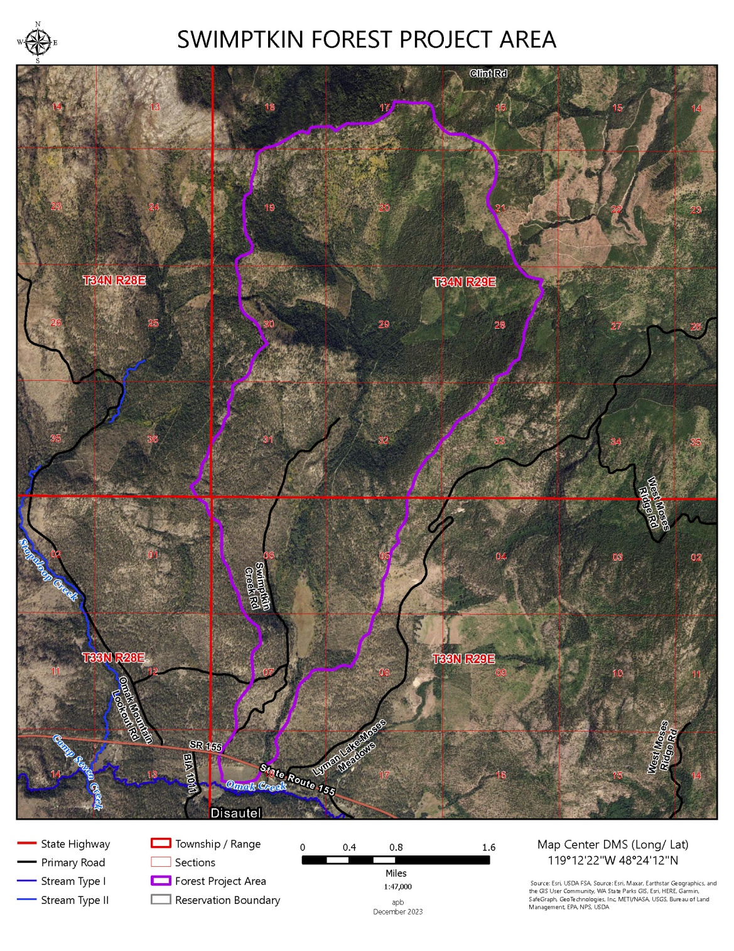
Figure 3. Ariel View of Proposed Swimptkin 2024 Project Area.
General Discussion
The Swimptkin Project area is located east of Omak, WA, in the Swimptkin Watershed Management Unit. The project lies west of Moses Mountain, and east of Omak Mountain. The project area is north of State Highway 155, bordered by the Stapaloop Creek Watershed to the west and the Clark Creek Watershed to the east. The total watershed project boundary encompasses approximately 5,767 acres. There is not any Fee ownership within the project’s boundary. Individual Indian Allotments make up approximately 236 acres. Subtraction of the 236 acres of Individual Indian Allotment ownership, gives a total of 5,531 acres of Tribal Trust lands within the project area.
Forest Health
Past management practices of fire suppression, reduction in grazing, and single tree selection had the cumulative effect of creating a forest that is very different ecologically than the historically. Another aspect of forest health is that of direct damage to trees by insects, diseases, and parasitic plants. The forest condition is described in detail in the 2023 CTCR Forest Management Plan and 2015 IRMP. Please refer to that those plans to understand the forest health issues occurring on the Colville Reservation.
The Swimptkin 2024 Forestry Project Area had last been managed around 2009. Previous harvest history shows a unique even mix of intermediate cuts such as commercial thins and regeneration cuts such as Seedtree/Overstory removals. Maintenance treatments are planned in many of these same blocks this entry. This was to revert the species composition back to Western larch/Ponderosa pine and release these species established by previous entries. A large ~2,000 acer prescribed burn is being planned by Mt. Tolman Fire Center along the eastern boundary of the Project. Majority of this area was treated in the 2009 entry. Primary goal of this Rx burn is a maintenance type burn to keep fuel loading at an acceptable level.
3.2 Soils
The landscape throughout the project area is dominated by mountain slopes, outwash terraces, and hillslopes. Soils are formed predominantly from glacial till, outwash, volcanic ash, and loess. Soil parent materials largely derived from glaciofluvial deposits and glacial till mixed with a component of volcanic ash and loess. Table 4 shows the general soil types and their landscape characteristics. Soils data for the Colville Indian Reservation comes from the detailed soil survey of the Colville Indian Reservation (NRCS 2002).
General Soil Types | Map Unit Names | Landform | Approx. % of Area
Sandy Loam | Stapaloop, Torboy, Merkel, Sacheen | Outwash Terraces, Mountain Slopes | 39.10%
Silt Loam | Louploup, Goddard, Nevine, Neuske | Mountain Slopes, Outwash Terraces | 26.20%
Loam | Donavan, Stepstone, Apex, Bernhill | Hillslopes, Mountain Slopes | 18.20%
Table 4. General soil types and their landscape characteristics of the project area.
3.3 Hydrology
The present condition of the affected environment is variable across the project area. The affected environment is influenced by the Swimptkin Project Area in the Omak District of the Colville Reservation located in northeastern Washington State. This project area is 5,767 acres, and contains the entire Swimptkin Creek WMU.
The Swimptkin Creek drainage is not influenced by any other watersheds. The drainage is oriented roughly north-south, with Swimptkin Creek flowing south before feeding Omak Creek. To the west, the Stapalook Creek drainage is oriented similarly, as is Clark Creek to the east. Each of these drainages is located in the Omak Creek RMU, which flows west into the Okanogan River. Omak Creek, and its tributaries, are the last water bodies on the Reservation to support anadromous fish.
To the north of the Swimptkin Creek WMU, the Lost Creek RMU, containing the Upper Lost Creek, Haden Creek, and South Fork Lost Creek WMUs, flows east and north across the Reservation boundary. These drainages do not affect the water quantity or quality in the Swimptkin Creek watershed.
In addition to direct impacts in the Swimptkin Creek watershed, landscape-scale impacts from activity in the Swimptkin Creek watershed would be detected in the main stem of Omak Creek. Generally, timber sales are active for five years after approval, resulting in five years of direct impacts from timber harvest, though indirect impacts can last longer. In the past five years (since 2018), one other green timber sale has occurred in the Omak Creek RMU: Jim Creek (2023). The Omak Creek RMU has also been subject to multiple large fires in the previous decade. Of the 122,112 acre RMU, 90,845.4 acres have burned since 2013 (74.4%). Most of these acres resulted from just three megafires: the 2015 North Star Fire (9,134.4 acres in the RMU), the 2015 Tunk Fire (71,422.6 acres in the RMU) and the 2020 Cold Springs Fire (9,524.9 acres in the RMU). Despite this enormous burned area, the Swimptkin Creek drainage remained largely untouched from wildfire impacts. Following these major fires, salvage harvest of burned timber was also carried out, including 3,815.11 acres in the Omak Creek RMU following the Tunk Fire. The Swimptkin Creek project area is located within Range Unit 10, and a small portion of Range Unit 5. Both range units are utilized by cattle, and would likely continue to be throughout the duration of the Swimptkin Creek Timber Sale.
Water resources in the project area include 20.27 miles of streams and 73.08 acres of NWI mapped wetlands, as well as beaver-influenced extended ponding along Swimptkin Creek and an unknown number of seeps and springs. Swimptkin Creek is the major watercourse through the project area, flowing north to south before joining Omak Creek. Tributaries to Swimptkin Creek include type 3 streams, which are generally perennial and fish-bearing, and type 4 streams, which are generally intermittent, high-gradient headwater streams. Swimptkin Creek itself is both perennial and fish-bearing, supporting a population of anadromous salmonids.
Water quality is monitored by the Environmental Trust Department on the main stem of Omak Creek just downstream of the confluence with Swimptkin Creek, though it is not measured specifically on Swimptkin Creek. For this reason, conclusions about the specific condition of water quality in Swimptkin Creek are somewhat more difficult to draw. Water quality monitoring and analysis from 2016-2021 identified exceedances of the standards outlined in Colville Tribal Code 4-8 Water Quality Standards at this monitoring location (Axthelm 2022). Omak Creek (at the OMK-32A monitoring location) exceeded the dissolved oxygen standard for Class II waters (8.0 mg/L) on 7/27/2021 (5.7 mg/L). The limit was also reached on 8/28/2019. Under the pH standard for Class II waters, Omak Creek should maintain a pH between 6.5 and 8.5. One value outside of this range (8.86) was recorded on 4/29/2020. During the analysis period, Omak Creek also recorded exceedances of the 6.45 NTU turbidity standard in 7 out of 17 observations (41.2%), with a high value of 18.1 on 4/28/2021. Interestingly, the temperature in this location was never recorded as being in exceedance of the requirements for a Class II water (18°C), though this is a recorded concern for anadromous salmonids in other reaches of Omak Creek. There were also no recorded exceedances of any lab metrics (fecal coliform, e.coli, ammonia, nitrate/nitrite, TKN and orthophosphates).
3.4 Fish and Wildlife
Wildlife
The Swimptkin 2024 Project Area supports habitat for a variety of birds including Northern goshawks, great gray owls, other raptors, pileated woodpeckers and other cavity nesters, gold and bald eagles, owls, and a wide range of songbirds. Habitat components that provide requirements for the highest concentration of birds are found in and around riparian areas and areas with deciduous vegetation. Other critical habitat components include large diameter trees, snags and an abundance of large woody debris.
Federally Threatened or Endangered Species
Section 7 of the Endangered Species Act (ESA) (16 USC 1531 et seq.) of 1973 as amended and its implementing regulations found at 50 CFR 402, require federal agencies to ensure that any action authorized, funded, or carried out by such agency is not likely to jeopardize the continued existence of any endangered species or threatened species or result in the destruction or adverse modification of habitat. Upon review of the location of the proposed action, consultation with the
The BIA and Tribal Wildlife Biologist determined that the proposed actions and associated activities would have ‘No Effect’ to threatened or endangered species, or candidate or proposed species, or suitable or critical habitat within the action area. Documentation is found in Appendix B.
Information for Planning and Conservation was acquired from the United States Department of Interior Fish and Wildlife Service (USDOI-FWS) for Endangered Species Act Species List. An Official Species List from the United States Department of Interior Fish and Wildlife Service (USDOI-FWS), is included as Appendix B.
Species | Scientific Name | Status
Yellow-billed Cuckoo | Coccyzus americanus | Threatened
Monarch Butterfly | Danaus plexippus | Candidate
Bull Trout | Salvelinus confluentus | Threatened
Canada Lynx | Lynx canadensis | Threatened
North American Wolverine | Gulo gulo luscus | Threatened
Whitebark Pine | Pinus albicaulis | Threatened
Table 5. US-DOI-Fish and Wildlife Service: Official Species List.
Bald and Golden Eagle Protection Act and Migratory Bird Treaty Act
The Bald and Golden Eagle Protection Act (16 U.S.C. 668-668c), of 1940, as amended, and Migratory Bird Treaty Act (16 U.S.C. 703-712), of 1918, as amended, prohibits anyone, without a permit, from “Taking” eagles or any bird, including their parts, nests, or eggs. Within this Act, eagles/nests/eggs/young are not to be “Disturbed” including agitated or bothered. Aerial surveys have been conducted in the past by the Colville Tribe to identify eagle and raptor nests. All known nests are buffered and have seasonal restrictions.
Other Species
The American Goshawk (Accipiter atricapillus) is a large forest raptor, strongly associated with mature forests where there is dense and closed canopy cover, open understory for flyways, and multiple canopy layers for protection. These attributes are critical for nesting and foraging for American Goshawks. Great gray owls (Strix nebulosi) share similar habitat requirements as the American Goshawk with the additional requirement of open meadows for hunting. Pileated woodpeckers (Hylatomus pileatus) and white-headed woodpeckers (Picoides albolarvatus) are residents of the project area. Woodpeckers seek habitat that contains large diameter trees and mature stands of timber with an abundance of woody debris.
The Swimptkin Project Area contains habitat that meets the life requirements of a variety of mammal species including snowshoe hares (Lepus americanus), mice (Cricetidae spp.), voles (Cricetidae spp.), beaver (Castor canadensis), several species of bat (Chiroptera spp.), coyotes (Canus latrans), black bears (Ursus americanus), bobcats (Lynx rufus) and cougars (Puma concolor). Reptiles and amphibians are also residents of the project area and are sensitive to habitat changes. Areas used for reproduction are among the most important areas to protect for these species. Each of these species would react differently to the impacts of logging operations but maintaining species diversity and structural complexity would ensure the continuance of the greatest suite of species.
Mule deer (Odocoileus hemionus), White-tailed deer (Odocoileus virginianus), Rocky mountain elk (Cervus elaphus nelsoni), and Moose (Alces alces) are culturally significant species to tribal members for both subsistence and ceremonial uses and are found within and adjacent to the project area throughout the year. Mule deer can be found throughout the area from steep forested ridges to lowland shrub-steppe habitat at all elevations. White-tailed deer are primarily found using riparian associated habitat adjacent to streams, rivers, meadows or agriculture at elevations below 3,500 feet. Elk are known to use portions of the area throughout the year, including calving grounds and winter range (low snow pack years).
The Colville Reservation is currently home to eight known wolf packs. Gray wolves (Canis lupus), as apex predators, play an important role in ecosystem function, preying primarily on ungulates such as deer, elk, and moose. Currently, there is a wolf pack utilizing the Swimptkin Creek area, with habitat and prey existing to support wolves. This area provides travel habitat and movement for resident and migrant wolves. Wolves in Eastern Washington are state threatened species, but not a federal listed species.
It is unlikely that Canada lynx (Lynx canadensis) are present in the Swimptkin Project Area due to its elevation and habitat type. Nevertheless, Lynx are known to utilize the habitat as transients. Additionally, pine marten (Martes martes), wolverine (Gulo gulo luscus), and fishers (Pekania pennant) historically have been documented on the Colville Reservation. These rare forest carnivores are extremely susceptible to logging and harvesting of old growth forests. Snags are used for denning sites, and the bigger snags should be left when possible.
Protection Measures
Wildlife buffers create travel corridors for wildlife and maintain habitat blocks utilized as thermal cover. Due to the smaller size comparatively to past sales and the linear shape of the overall sale, the Swimptkin timber sale would have zero wildlife buffers placed added. The blocks were either reshaped, reduced, erased, or the block was not large enough to need a reserve patch per code 4-7. The sale initially started at an overall acreage of 1,713.4; the final acreage after reshaping the blocks totaled 1522.5, for a total reduction of 190.9 ac (11.1%).
In the Swimptkin Project Area there is approximately 1,027.3 acres of blocks that are adjacent to streams; that is of the 28 blocks in the Swimptkin Project Area, 17 (60.7%) contain or are adjacent to streams. These bodies of water include but are not limited to Swimptkin Creek and a number of unnamed type 3 and type 4 tributaries, and all contributing streams in each watershed. Harvesting close to or near these bodies of water would allow for increased sedimentation, temperature, decreased supply of woody debris for invertebrates, an increase in turbidity, all of which would lead to a reduction in fish habitat as well as water quality. These streams and their associated riparian habitat have some of the highest fish and wildlife richness and diversity and are very susceptible to any environmental change.
The proposed action of the Swimptkin Project falls within one of the Reservation WMUs which is the Swimptkin Creek WMU. The CTCR IRMP has a target of 3.5 mi/mi² of tribal road during the sale with open road density to be reduced to less than 1.5 mi/ mi² wherever feasible across the Reservation. Road densities on the reservation are calculated using the WMU boundaries.

3.5 Cultural Resources
National Historic Preservation Act (NHPA)
Section 106 of the National Historic Preservation Act (NHPA) as amended, and its implementing regulations found at 36 CFR Part 800, require federal agencies to identify cultural resources for federal action. The significance of the resource must be evaluated using established criteria outlined at 36 CFR 60.4. If a resource is determined to be a historic property, Section 106 of the NHPA requires that effects of the undertaking on the resource be determined. A historic property is “…any prehistoric or historic district, site, building, structure or object included in, or eligible for inclusion in the National Register of Historic Places, including artifacts, records, and material remains related to such a property…” (NHPA, 16 USC 470w, Sec. 301[5]).
“Cultural resources” include archaeological sites, standing structures, and locations or landforms that are important to the identity of the indigenous people of the area (i.e., traditional cultural properties [TCPs]). For more details on the affected cultural environment, please consult the CCT Cultural Resource Management Plan (CCT 2007), the cultural resources overview for the Colville Reservation (Gough 1990), and the FEIS for the IRMP (CAR 2018).
The Swimptkin Creek Forestry Project is within the ancestral lands of the Okanogan Tribe, who can identify their ancestry back over a thousand years in this area. The languages of the twelve tribes comprising the Confederated Tribes of the Colville Reservation have been grouped into general Salishan and Sahaptian language families. The majority spoke the Interior Salish languages of nxaɁamcín and nsləxcín, though the Sahaptian languages of the Nez Perce (nímípuɁ) and Palus (palús) were also spoken. The language of the Okanogan is nsləxcín.
This project includes various forest management treatments for approximately 1,694 acres of land within the Omak/Nespelem Forestry District (OND). The project area encompasses approximately 5,870 acres. For the purposes of consultation with the Tribal Historic Preservation Officer (THPO) under Section 106 of the National Historic Preservation Act, the 1,703 acre timber treatment areas, prescribed burn block, attendant landings, any road construction and reconstruction as well as all existing roads utilized for logging operations shall be considered the Area of Potential Effect (APE).
Approximately 247 acres were previously surveyed within and immediately adjacent to the Swimptkin 2024 Forestry Project area (Rice & Stevens 1988, Gough 1990; Meyer 2005; Finley 2006; Meyer 2006 (1); Meyer 2006(2); Harder 2007). These inquiries have resulted in documentation three archaeological sites within or immediately adjacent to the Swimptkin 2024 Forestry project area and a review of the Colville Confederated Tribe History/Archaeology Program documented three Traditional Cultural Properties (TCPs) within the project area (Table 7) for a total of six cultural resources.
A search of Bureau of Land Management/General Land Office (BLM/GLO) records indicates that there are six historic Indian allotments documented three land patents, 2.3 miles of historic roads, 4.2 miles of historic trails and one GLO Structure documented here.
For the current project, a predictive model was used to select areas within the Swimptkin Creek Project area for a cultural resource survey.
Table 6. Cultural Resources Recorded within and adjacent to the Swimptkin Creek Forestry Project Area*.
Site ID Number | Site Name | Site Description
45OK514 | Narrow Gauge Railroad | Historic Logging Property
45OK515 | “C” Line Historic Dump | Historic Scatter
45OK2406 | Nancy Swimptkin Allotment | Historic Homestead
CCT-WA-OK-123 | Disautel Residential Area | Traditional Cultural Property
TCP-WA-OK-16 | Skunk Takes Revenge | Traditional Cultural Property
TCP-WA-OK-85 | Omak Creek Fishing Area | Traditional Cultural Property
*Archaeological and sacred site locations are not provided in this document because disclosure of site locations may put these resources at risk to vandalism and looting (see the National Historic Preservation Act of 1966, Section 304a; and the Archaeological Resources Protection Act of 1979, Section 9a) or jeopardize their access, integrity and ceremonial use (see Executive Order No. 13007).
None of the six cultural resources identified within/adjacent to the entire project area are located within the APE for the current project.
It is likely that cairns, rock alignments, and other rock features may be found throughout the area due to the prominent landscape of the mountains in the area. Small pre-contact camps may be present on the upland areas adjacent to springs or creeks, or in sheltered canyons, where people would have camped while taking advantage of upland resources. Evidence of early historic-period occupation, logging and mining features and\or graves may be present within the project area. It is also likely that eagle feather collection areas are utilized by current Tribal members, given the proximity to the Columbia River.
The project area is located within the Omak Watershed, which contains twelve springs and all or portions of Tunk Creek, Stapaloop Creek, Swimptkin Creek, Clark Creek, Camp Seven Creek, Trail Creek and Summit Lake. Land-based cultural activities occur in the summer and fall within this watershed, with the most prevalent use during the summer. Traditional use of sweathouses perpetuates within the Omak Creek watershed, as do harvest of culturally significant plant species across the landscape. Six locations within the watershed have been documented as important areas for water-related resources and legendary landscapes. Some of these areas include Swimptkin Creek, Omak Creek and Clark Creek. The project area falls within a portion of the watershed which is documented as a principle gathering location for at least seventeen native plant species for consumption, construction, weaving, and religious purposes (Table 7).
Table 7. Traditional Cultural Plants gathered within the Omak Creek Watershed (Marker et al. 2011).
Arrow-leaf balsamroot,  Balsamorhiza sagittata | Ponderosa Pine,  Pinus ponderosa | Lichen,  Lewisia rediviva
Bitterrot,  Lewisia rediviva | Foamberry,  Shepherdia canadensis | Chokecherry,  Prunus spp
Hawthorn (Red or Black),  Crataegus spp | Elderberry (Blue or Red),  Sambucus spp | Huckleberry,  Vaccinium spp
Fir,  Multiple Species | Red Willow (Dogwood),  Conrus stolonifera | Green Willow,
Tule,  Schoenoplectus actus | Bunchgrass, | Cedar,  Thuja plicata
Lodgepole Pine,  Pinus contorta | Western Larch,  Larix occidentalis
3.6 Range Management
All of blocks listed in the project attribute table are within the range programs stewardship area Range Unit 10 with exception of blocks 119, 222, and 2493-B. The infrastructure GIS layer indicates possible impact to range fence with Blocks 15, 253, and 794 near the southeast boundary of the grazing unit. No other potential infrastructure impacts are identified within the unit using the GIS layers. Range assets may exist that are not recorded in the range program’s infrastructure layers. The CTCR Range Program requests that if infrastructure is encountered, we be notified as to type and location so that the structures can be assessed as to condition to determine if repairs are needed or if the structure materials should be removed from the forest. Additionally, if viable infrastructure is damaged during project activity the project proponent will be responsible for notifying the range program and seeing that damage is repaired in a timely manner. There are grazing permits issued in this range unit. Livestock can be expected to be present during the grazing season May 15 to October 31. The range program asks that any gates opened while livestock are scheduled to be grazing be closed as soon as passing through the gate. As well, any concerns of interaction between livestock and logging activities be addressed in a timely manner to the range program.
3.7 Air Quality

Smoke Management and Air Quality

A. Compliance: Air quality within the reservation boundaries is regulated by the Environmental Protection Agency (EPA) under 40 CFR, Part 49, Section 131,137 Federal Air Rules for Indian Reservations (FARR) effective June 7, 2005. Implementation of this prescribed fire plan would comply with FARR regulations.

B. Permits to be Obtained: No permits are required to implement this Prescribed Fire Plan. Dispatch would notify Washington State DNR of intent to burn on a daily basis.

C. Smoke-Sensitive Receptors: There is no Class I air - sheds adjacent to or within the boundaries of the Colville Confederated Tribes Indian Reservation. The following small airports border the reservation boundary but would not be impacted.
D. Potential Impacted Areas: Smoke as a result of ignition, would be transported into the higher levels of the atmosphere by general and transport winds minimizing smoke impacts to the public during the day. Some significant smoke impacts are anticipated. The volume of smoke created on any given day is not anticipated to be enough to create a significant impact within the Swimptkin creek drainage.

Mitigation Strategies and Techniques to Reduce Smoke Impacts: The Burn Boss would coordinate on a daily basis with the Operation Specialist in scheduling and prioritizing prescribed fire activities across the Colville Indian Reservation. By doing so, air quality can be managed and duration of smoke exposure minimized.
- Prior to the planned burn day(s), Fire Management staff would post public notification posters that display areas where burning is planned and would include Fire Management contact information if public has questions or concerns.
- If there is an expectation that nearby local residents would be impacted by smoke, the Burn Boss would arrange for fire management staff to contact them. If personal contact cannot be made a flyer would be left that would include Fire
- Management contact information. The Burn Boss would attempt to manage smoke impacts where necessary by limiting the number of acres burn in the area each day.
- No local residents with respiratory health issues have been identified at this time. Temporary living arrangements would be offered if a resident is identified.
If roadway visibility is impacted signs would be posted as required in the State and County Signing Guidelines.
3.8 Fuels/Fire Management
80 years of active fire suppression has negatively altered plant community composition, structure, density and fuels loading within the project area. Prior to the more recent period of active fire suppression, fire was an important ecosystem component that helped maintain resilient ecosystem functioning. Fire on the landscape helped the fire adapted vegetation species occupying these sites maintain healthy resilient plant communities. An integrated management approach wherein Fire Management and Forestry work closely together to plan and implement Forest Management Projects that would benefit the resource and membership while reducing costs and increasing the number of acres receiving treatment.

Stand Composition Density, Structure and Fuel Loading
Currently stands in the project area are varied depending on length of time since last treatment. Some stands are over stocked, with a closed canopy of young trees that are in need of thinning. Some are multi-storied structure due to seeding in from over story trees. The risk of catastrophic wildfire is greater in these stands than would have normally occurred, due to dense stocking or ladder fuel conditions that would allow fire to spread into the forest canopy.
Due to the past activities in the Swimptkin Project Area the condition class of the sites has had some departure from the normal historic range. Please see Appendix G for description of Fire Regimes and Condition Classes. Condition Class 2 is the most prevalent within the project area at 3,899 acres within the treatment areas, with 2,569 Acres of Condition Class 1, and 118 acres in condition class three. Please note that Condition Class acres do not equal treated acres due to the classifications of Barren and Sparsely Vegetated are not included in Fire Regime Condition Class calculations, and the total is of the project acres, not treated acres. As a result of these past harvest treatments condition class has improved and stand conditions are closer to their normal historic range.
4.0 Environmental Consequences
Summary Table of Issues Indicators
Table 8. Summary table of issue indicators for goals and objectives.
Resource | Issue | Issue Indicator | Alt. A | Alt. B
Vegetation/Timber | Forest Health | Acres Treated | 0 | 1,694 ac
 | Support of Tribal Wood Processing | Timber Volume for Processing | 0 | 8.3 MMBF
 | Tribal Income | Projected Stumpage | $0 | $2.1 Million
4.1 Forestry
Impacts to Forestry Resources Alternative A: No Action
• No profits for Colville Tribe and would not meet the AAC of 77.1 MMBF.
• Forest management would not receive the 10% funds.
• No timber industry employment would be generated.
• Forest health would decline.
• No Improvements in forest roads.
• Area would move farther away from the Desired Future Condition’s in the Integrated Resource Management Plan.
• No new acres would be added to the regulated forest.
Under this alternative, no conifer trees would be harvested. No timber stumpage revenue would be generated. No Forest Management Deduction (10%) funds would be generated. No logging industry employment would be generated. No silvicultural treatments would be implemented. Forest health issues and concerns could possibly worsen, and the desired objectives would not be achieved in regards to desired future conditions. Overstocking of forest stands; predominance of climax tree species, over mature trees, tree mortality, competing vegetation, forest insects and diseases problems and other current forest conditions would continue to affect the overall forest health. The potential forest site-productivity may never be achieved on some locations.
Forest roads would not be maintained and/or reconstructed, and potentially upgraded by culvert installation and erosion control which would affect the access and use of resources by the Colville Tribe and public. Under-sized culverts and plastic culverts would not be replaced.
Impacts to Forestry Resources Alternative B: Proposed Action
- $ 2.1 million dollars of profit for the Colville Tribe with a harvest of 8.3 MMBF
- Species composition on 1,694 acres would be shifted to managed Ponderosa pine and Western larch
- Forest health would improve, diseased trees would be lessened, and disease-resistant species would be regenerated naturally and with planting
- Understory Douglas-fir, Subalpine/Grand Fir, Lodgepole Pine encroachment would be piled and/or burned, reducing the likelihood of catastrophic fire and prepare site for regeneration of desirable species
- Density would be reduced in overstocked stands, creating a healthier forest
- Desired Future Condition’s outlined in the IRMP would be met over time
- 26.5 miles of existing road would be improved
Some of the potential negative impacts that a timber sale may create, include the following: Visual landscape changes or disturbances would occur. Man-made “signs” (ribbon, tags, paint) are introduced into the area to guide the forest management. Noise and dust are created from logging operations. Existing vegetation is temporarily disturbed, but their resiliency to disturbances would allow them to come back. Skid trails and landings are created. Woody slash material is created.
4.2 Soils
Impacts to Soil Resources Alternative A: No Action
The “no action” alternative would have no impact on the soil resource within the project area.
Impacts to Soil Resources Alternative B: Proposed Action
Soil would be impacted by ground-based logging, tethered logging, excavator piling, pre-commercial thinning, and broadcast burning. Approximately 1,204 acres would undergo ground-based logging. Blocks that are cable logged and/or tethered logged, comprising approximately 318 acres, typically have fewer significant soil impacts. If tethered logging is used instead of cable, soil impacts would vary depending upon localized conditions, but tend to improve overall safety. Approximately 2,061 acres would undergo hazard fuel reduction (likely a prescribed burn), at least 55 acres would be excavator piled, 172 acres would undergo pre-commercial thinning, and 500 acres would undergo lop and scatter. Approximately 1,392.40 acres (38.36%) of potential prime farmland exist within the commercial harvest blocks and broadcast burn areas. Prime farmland within the project area is located within forested land that is part of the CTCR designated commercial timber base. It is unlikely that timber harvesting would have any detrimental effect on the functional integrity of the land classification and CTCR does not have future plans to develop the prime farmland within this project area.
Generally, areas with slopes exceeding 35% are less well suited to use of ground-based machinery and soil impacts would be greater. According to data obtained from the Colville Tribes RIA/GIS program, 0 percent of the total 1,204 ground-based logging acres of the proposed blocks in this project have slopes exceeding 35%, meaning the total ground-based treatment area with slopes exceeding 35% would be 0 acres. Anticipated soil impacts include displacement of topsoil, rutting, compaction, and erosion or soil loss. Ratings of potential for soil degradation are provided by the Natural Resources Conservation Service. Table 9 shows the number of acres of ground-based harvest classified by soil displacement, rutting, compaction, and erosion hazard ratings:
Table 9. Ground-based harvest acres with soil degradation ratings.
Soil Degradation Type | High Potential | Moderate Potential | Low Potential
Displacement | 258.8 Acres | 930.4 Acres | 15.1 Acres
Rutting | 918.7 | 229.8 | 55.8
Compaction | 917.3 | 284.4 | 2.5
Erosion | 84.1 | 835.5 | 284.7
The Natural Resources Conservation Service rates most soils with slopes exceeding 20% as poorly suited or unsuited for surface mechanical site preparation. Approximately 95.42 percent of the total harvest acres blocks in this project have slopes exceeding 20%. The primary factor limiting suitability is hill slope. Anticipated soil impacts include displacement of topsoil and erosion.
Skid trails and pile burning generally cause severe impact to the upper soil layer (Cooley 2004). Skid trail impacts include compaction, rutting, and erosion or soil loss. Pile burning consumes most soil organic matter, nutrients, while changing the texture of soil surface layers.
Approximately 2,061 acres are proposed for prescribed broadcast burning. Of the entire project area 70.2 percent of the total area is considered by NRCS to be highly susceptible to fire damage and 28.9 percent moderately susceptible, primarily due to subsequent water and wind erosion. Higher impact is associated with higher burn severity, with low severity burns posing less risk of soil damage.
Any new road construction likely involves clearing and grubbing, excavation, and compaction of multiple acres of soil depending on the mileage of new road. According to the project shapefile, approximately 1.7 miles of new road construction and 26.5 miles of road reconstruction would occur. With a total of 28.2 miles of new road construction and road reconstruction, approximately 112.8 acres of soil disturbance would occur.
Standard Operating Procedures and Mitigation Measures
All applicable Best Management Practices (BMP) specified in Tribal Code CTC 4-7 Forest Practices are required to limit soil damage (CTCR 2023).
Overall, activities should be performed when soil conditions are not likely to result in excessive erosion or soil movement, considering soil types, slopes, and climatic conditions.
Avoid developing prime farmland where possible to preserve those portions of the reservation which contain prime agricultural soils for agricultural purposes.
Increased soil impact is associated with higher burn severity; therefore, implementation of broadcast burning should maintain low severity burns in order to reduce soil damage.
4.3 Hydrology
Impacts to Hydrology Resources Alternative A: No Action
The no action alternative would allow for the natural ecological process to continue. Stream channel hydraulics and associated riparian vegetation would not be impacted by harvest related activities. Effective ground cover and hydraulic roughness would remain, continuing to provide overland flow attenuation and prevent nonpoint source pollutant delivery to downslope watercourses. Retention of mature vegetation would continue to provide canopy interception and reduced rain splash erosion. Infiltration would remain high, and rill and scour erosion would remain minimal. Additionally, soil structure would be maintained in the current state. All methods of timber harvest, ground- or cable-based, result in some amount of soil disturbance. Soil compaction generally occurs in locations where machinery tracks have traveled (particularly in wet conditions), while destruction of soil structure and subsequent sediment mobilization generally occurs as a result of ground-based operation on steep slopes and a lack of traction. Transport of trees by logging equipment also results in soil disturbance and transportation. These effects would be avoided through the No Action Alternative, maintaining soil structure, density, and productivity.
Road density would be maintained at the current level under the No Action Alternative. Existing road density in the Swimptkin Creek Watershed Management Unit (WMU) is higher than the desired condition outlined in the IRMP (Existing: 6.1 mi/mi²; Desired: 4.0 mi/mi²), but lower than the density that would be achieved as a result of the preferred alternative. The No Action Alternative would also not involve reconstruction of any existing roads, allowing existing vegetative cover and stability to be maintained. Maintaining the lowest road density (i.e. the existing condition) would provide the closest approximation of natural hydrologic conditions, between the two scenarios. High road densities are detrimental to watershed hydrology primarily due to the interception and diversion of water from natural flow paths. When water flowing down a hillslope is intercepted by a road prism, ditch, blocked or undersized culvert, or other infrastructure, that water is generally diverted or lost to evaporation, rather than continuing as overland, shallow subsurface, or groundwater flow. As climate change advances, it becomes increasingly important to retain water on the landscape. High road density contributes to the loss of water on the landscape through decreased infiltration and increased evaporation, and each additional road increases these effects.
Existing roads in the Swimptkin project area are maintained to various levels of stability. 23 existing segments, with a total length of 5.29 miles, were identified for review; segments were selected for review if they were within or adjacent to swales, draws, wetlands, streams, or other aquatic resources. Additionally, some segments had previously received restoration treatment, and were identified to prevent unauthorized use. Under the No Action Alternative, none of these segments would be reconstructed, and use would not increase. However, segments that have not been maintained may continue to be at risk of failure, and crossings obstructing flow and fish passage would continue to do so.
Impacts to Hydrology Resources Alternative B: Proposed Action
- 1.7 miles of new road construction and 26.5 miles of road reconstruction
- 0.06 miles of new construction and 2.31 miles of reconstruction within 200 ft of streams
- 0.11 miles of reconstruction within 200 ft of wetlands
- Harvest activities within 200 ft of streams – 109.63 ac
- Harvest activities within 200 ft of wetlands– 13.44 ac
The proposed action would involve 1,522 acres of timber harvest. Throughout the project area, these activities overlap and abut streams and wetlands, with 123.07 acres of harvest activities within 200 feet of wetlands and streams.
Harvest operations, including the use of heavy machinery to fell and skid timber, cause soil compaction and erosion; additionally, as a result of decreased vegetation, interception, infiltration and water use are decreased, and a greater volume of water occurs as overland flow. This can result in great sediment transportation to downslope streams and wetlands, resulting in decreased water quality. Additionally, harvest operations create linear features such as skid trails. If oriented parallel to the slope, or located in swales and topographic low points, these linear features channelize water, and lead to rill and gully erosion, sediment transportation, and road failure. These effects can be minimized by locating skid trails perpendicular to slope direction, and through the use of cable logging rather than ground based harvest systems, particularly on steeper slopes.
All road construction and use associated with proposed timber harvest activities would lead to soil disturbance and loss as well as alteration of watershed hydrology (Hunner 2014). Specifically, road miles within 200 ft. of surface water are statistically likely to deliver sediment/erosion to surface water (Dubé et al 2004). Road reconstruction and new construction effects on water quality, hydrologic processes, and aquatic habitat would be the longest-on-going, longest-lasting, and highest-degree negative impacts resulting from the proposed action. The use of heavy machinery to create and redo roads would result in immediate sediment delivery to adjacent waterbodies. Additionally, reconstruction results in soil compaction and disturbance, both of which are significant causes of decreased soil health, eventual runoff channelization and continued erosive losses. Repeated improper reconstruction procedures that fail to reincorporate disturbed material into the road prism create linear features that channel water away from natural water features. When these features are created adjacent to streams, heavy flow events can cause the relocation of the active channel into the road prism, creating a safety hazard, and drastically altering the natural hydrology of the area.
Water Resources
Table 10. Hydrologic features within the Swimptkin Project Area footprint.
Hydrologic Feature | Potentially Affected Size
Mapped Streams | 20.27 mi
Mapped Wetlands | 73.08 ac
The impacts from the proposed project to the affected environment are multi-faceted. Harvest impacts include: alterations in flow paths due to skid trail creation and machinery operation; reduced infiltration and increased erosion due to soil compaction from machinery operation; increased sediment and nutrient delivery to surface waters; loss of wetland and riparian vegetation; and potential delivery of herbicide to surface waters, among others.
Prior to initiation of harvest, calculation of exact miles of skid trails is not feasible. However, impacts can be estimated through looking at the number of blocks and acreage of harvest impacts. 1,522 acres, across 28 blocks, are proposed for ground based (tractor and cable assist) harvest. Blocks range from approximately 1,500 to 5,000 feet in width oriented perpendicularly to the hillslope. Assuming an average block width of approximately 2,000 feet (a conservative estimation), with average skid trail spacing of 100 feet (as required by Colville Tribal Code 4-7 Forest Practices), at least 560 skid trails would be created in blocks prescribed for ground based harvest. Using aerial imagery from late summer 2022, skid trail spacing in previous sales, including the Haden Creek 2020 Timber Sale, was determined to be closer to an average of roughly 50-75 foot spacing. With this knowledge, we can assume that skid trail creation could be as much as 1.5 to 2 times greater than what is estimated above in ground-based harvest blocks. Additionally, 122.74 acres of proposed ground based harvest would occur within 200 feet of hydrologic features. The potential for sediment and nutrient delivery to surface water via skid trail creation is elevated in these acres.
Tethered logging, a relatively new harvest system on the Reservation, which involves the use of a winch for assistance in machinery operation of slopes, is proposed for 318.2 acres of blocks. Existing Tribal Code does not allow for operation of ground based harvest systems on slopes over 35% due to potential soil impacts, recognizing the increased magnitude of machinery impacts as slope increases. However, tethered logging has been adopted for use on slopes up to 70%, to increase efficiency and decrease costs of harvest. Where any ground based harvest system is used on vulnerable soils, the potential for compaction and erosion is increased. When these factors are combined with steep slopes and proximity to aquatic resources, the potential for sediment delivery and resource damage is increased 25.62 of these acres are located within 200 feet of streams, increasing the potential for sediment delivery due to the combination of ground based operation and steep slopes.
Road development and use impacts include: alterations in flow paths due to the creation of linear landscape features (roads) perpendicular to natural slopes; reduced infiltration and increased erosion due to the creation of impervious or resistant surfaces; and increased transport of vehicle associated contaminants (including 6PPD-q, hydrocarbons and carbon monoxide from exhaust, etc.), among others.
Proposed reconstruction and new construction in the Swimptkin project area would occur on 28.2 miles of road. The proposed haul route for logging vehicles to transport logs to the mills includes an additional 90 miles of paved road between the project area and the northern boundary of the Reservation in Inchelium. This route would take log trucks down State Highway 155 to the town of Nespelem, over Cache Creek Road, SR 21, and Bridge Creek Road to the town of Inchelium, and up Inchelium-Kettle Falls Road to the reservation boundary to haul to mills in Colville and Kettle Falls, WA. 2.37 miles of reconstruction and new construction would occur within 200 feet of surface water. 0.11 miles of road reconstruction would occur within 200 feet of wetlands. High road densities detrimentally affect water retention on the landscape, creating interception points that redirect flow from reaching creeks, streams, and wetlands. Abandonment and revegetation of roads can mitigate some of the effects of high road density, improving infiltration and decreasing overland flow, but retention of road prisms, nonnative road bed material, and artificial crossing structures such as culverts would continue to alter hillslope hydrology regardless of vegetation establishment. Additionally, studies have shown that the chemical 6PPD-quinone, used in the manufacture of rubber tires, can cause acute mortality in salmonids, including rainbow trout (Oncorhynchus mykiss), found in streams across the Colville Reservation. Roads in proximity to salmonid bearing waters may result in 6PPD-q related effects.
Surface Water:
The proposed alternative would generate sediment through the creation of skid trails, increase overland flow through the removal of vegetation, and create interception points through the construction and reconstruction of roads. A minimum of 18 culverts and rock fords would likely be installed or replaced during this project. Road miles and road density in the project area would increase due to the 1.7 miles of new road construction.
Wetlands:
The proposed forestry activities would impact wetland ecosystems through soil disturbance, hydrological alteration, and disruption of vegetative community. Forestry associated road work, including 0.11 miles within 200 feet of wetlands and additional impacts to beaver-influenced extended ponding along Swimptkin Creek adjacent to Block 148 253.
Floodplains:
NOAA mapping indicates a limited 100-year floodplain associated with Swimptkin Creek. Due to the relative confinement of the drainage and the steep slopes in the Swimptkin Creek WMU, tributaries to Swimptkin Creek are generally confined, and do not have associated floodplains. Blocks and roads proposed for this project do not encroach on the 100-year floodplain of Swimptkin Creek.
Direct Impacts – Short-Term
Surface Water:
Timber harvest activities are likely to result in short term impacts to surface water quality through the generation of sediment. Turbidity has previously been an issue in Swimptkin Creek; this is likely to continue, and detrimentally affect aquatic organisms. Additionally, turbidity is often associated with dissolved oxygen, which has also been a metric of concern in this drainage in the past, and temperature, which is a particular concern to anadromous salmonids. Increased heating of surface water, particularly in headwaters and tributaries, is likely, due to removal of vegetative cover. Degradation of temperature, dissolved oxygen, and turbidity metrics would likely be short term impacts of timber sale activities. Water quantity is the main stem of Swimptkin Creek likely to increase in the short term, due to removal of vegetation and reduction of transpirative losses. However, much of this water would travel as overland flow, becoming vulnerable to evaporation and interception from road prisms, skid trails, and other anthropogenic alterations. Water distribution across the landscape is likely to change for this reason. Road construction and reconstruction is responsible for interruption of natural landscape hydrology, creating diversion points perpendicular to hillslopes. These diversions result in altered flow paths, increased evaporation, and increased sedimentation. Short term water quality would likely decrease for these reasons as well. These impacts would be sustained over the duration of the project, approximately five years.
Wetlands:
Moderate tree removal surrounding the depressional wetland in the Overstory Removal Cutting (OR) Rx Block 156 010 as well as adjacent wetlands in Block 148 119 and especially extensive removal for Seed Tree Cutting (ST) Rx adjacent to Block 148 253 are predicted to contribute to short-term rise in local water tables which influence the timing and seasonal persistence of surface water, interrupt pollutant processing capacity of the wetlands, and disrupt growth habits of wetland vegetation. Road construction and use through Block 148 253 (FID 1414) is predicted to interrupt subsurface flow paths and contribute to excess sediment delivery to beaver-influenced extended riparian wetlands associated with Swimptkin Creek.
Direct Impacts – Long-Term
Surface Water:
Long term impacts to surface water would continue until vegetation is established and disturbed areas are stabilized. As skid trails and roads are seeded with herbaceous vegetation, soils would become more stable, and water quality would gradually return to pre-harvest conditions. As larger vegetation and trees establish, surface water quantity would decrease with increased evapotranspiration. Depending on the duration and severity of impacts to natural hillslope hydrology, flow paths may be permanently altered by the creation of skid trails and roads. Additionally, roads would not be deconstructed at the conclusion of the sale. Therefore, road density impacts on interception and diversion would persist, and road use would continue into the foreseeable future. Crossing structures would also not be removed, and impacts from improperly installed or sized structures would continue to impact water quality in the long term. Additionally, any road use over streams would continue to deliver sediment and contaminants to the surface water at the crossing.
Wetlands:
There are 0.11 miles identified for reconstructed road within 200 feet of wetlands. RMZ buffers. Over the long-term the construction and use of forestry-related roads contributes to sedimentation in wetlands, aiding in nutrient and pollutant delivery as well as degrading wetland function, water quality, and habitat.
Cumulative Impacts
Surface Water:
As discussed above, one other timber sale has occurred in the Omak Creek RMU in the past 5 years. The Jim Creek Timber Sale encompassed several drainages upstream of Swimptkin Creek, as well as a portion of Omak Creek below the confluence with Swimptkin Creek. The Jim Creek Timber Sale also proposed the harvest of 40 MMBF of timber over 7,402 acres, which was considerably higher than the estimated volume recorded on the harvest schedule. For this reason, it is highly likely that the above described short and long term impacts of timber harvest in the Jim Creek project area would be substantial; additionally, due to the four year overlap in harvest periods, these impacts are likely to combine with impacts from the additional 1,522 acres of timber harvest in the Swimptkin timber sale to cumulatively impact the water quality and quantity in the Omak Creek RMU. Each acre of timber harvest results in sediment generation, nutrient transport, and hydrologic alteration. Additionally, cattle presence in the project area is likely already degrading water quality. Cattle impact water quality through bacteria and nutrient delivery (specifically nitrogen and phosphorus), as well as erosion and sedimentation through hoof shear and trampling. These impacts are likely to continue throughout the duration of the timber sale and afterwards, contributing to increased cumulative effects on water quality.
Wetlands:
Increased runoff and sedimentation associated with ground based harvest systems and road construction, reconstruction, and forestry related road use are expected to have cumulative systemic impacts to the wetlands adjacent to harvest blocks as well as the downstream wetlands associated with Swimptkin Creek. There are currently damaged or no grazing controls for range practices along Swimptkin Creek and the associated wetlands. Cattle impacts including wetland soil disruption and biological impacts would be exacerbated by forest practices contributing to excess sedimentation and nutrient inputs.
Water Resources Impacts – Conclusions

Water Resource Type | Short-Term Direct Impacts | Long-Term Direct Impacts | Indirect Impacts | Cumulative Impacts
Surface Water | Yes | Yes | None | Yes
Wetlands | Yes | Yes | None | Yes
Floodplains | None | None | None | None
Table 11. Water Resources Impact Summary from the Proposed Action.
The project would result in short term impacts to soil and surface water, particularly within the top 12-24 inches. Long term impacts (after the conclusion of the project) would be reduced as vegetation reestablishes and stabilizes slopes, though impacts from road construction and use would continue indefinitely. However, the cumulative impact of the project, in conjunction with previous timber sale impacts, would impact water quality and quantity throughout the Omak Creek RMU. The Proposed Action would result in considerable short term and cumulative impacts to water resources including surface water and wetlands.

Resource Use Patterns
Transportation Networks
The existing transportation network on the Reservation consists of nearly 10,000 miles of road managed under multiple jurisdictions, maintained to varying degrees of stability. Within the Omak/Nespelem district, major travel corridors include State Route 155 (Washington State DOT), Cache Creek Road (Okanogan County Public Works), and Columbia River Road (BIA DOT), among others (Tribal DOT, etc.). Additionally, the district contains multiple thousands of miles of forest roads, which do not fall under any of the above jurisdictions, and therefore do not receive any maintenance. These roads are primarily used for timber harvesting, fire suppression, and member access for hunting, fishing, and gathering. In addition to this multi-jurisdictional network, there are over 3,300 stream crossings.
Mitigation and Monitoring Requirements
Operators must ensure that all Best Management Practices (BMP) and standards for timber harvest identified in Colville Tribal Code (CTC) Chapter 4-7: Forest Practices are followed in order to minimize hydrologic disturbance resulting from actions taken under this alternative. During road construction and reconstruction Planners and Operators must ensure that new/re-constructed roads meet the BMPs and standards for roads identified in CTC Chapter 4-7: Forest Practices, and CTC Chapter 4-9 Hydraulic Projects if doing any culvert/bridge work. By meeting these BMPs Planners and Operators will minimize the water quality, hydrologic process, and aquatic habitat degradation associated with roads as a result of the actions taken under this alternative. The transportation plan developed by the Omak-Nespelem Forest Roads Engineer incorporated input from the Environmental Trust Department regarding stream adjacent roads, new road locations, and culvert sizing and placement. The Forest Roads Engineer should continue to work with the Watershed Restoration Program to remove any unnecessary road construction, and determine where roads can be closed or decommissioned to reduce road density.
A preliminary transportation memo was distributed on 2/1/23 identifying roads that should not be used due to stream or wetland adjacency. These segments were then field verified, and adjustments were made accordingly. Several segments identified for review overlapped with roads proposed for use in the sale; after field assessment, these segments were removed from the transportation plan.
A layer was also provided of all restored roads within the project area, including decommissioning, closure, and permanent abandonment. In the original preliminary transportation memo, the following was stated: “Multiple restoration projects in and around this timber sale area have been completed, including a 2006 319 Road Maintenance project, a 2016 Omak Creek Watershed Road Decommissioning project, and a 2006 Fish and Wildlife funded project. Eleven decommissioned road segments are within the Swimptkin sale area; these roads are not available for use.” Road segment FID811 overlaps a road that was decommissioned by the Fish and Wildlife Department in 2017, which was identified on this original layer. The road segment was discussed multiple times at meetings and during field tours; ultimate decision on road use falls to Fish and Wildlife.
The provided culvert shapefile identified 18 proposed culvert and ford installations or replacements. Based on Streamstats analysis of culvert sizing, as well as field analysis of installation and integrity, eight crossings had additional comments; the following table, along with a shapefile titled “ETD Culvert Notes”, were provided to the Transportation Planner on 10/4/23:
Table 12 . Crossings with ETD Mitigations.
ETD ID | Existing Crossing | Proposed Crossing | ETD Mitigations
1 | Ford | 24” CMP or ford | Rocked ford preferred
2 | - | - | Severe rill erosion, do not use road  Road removed from transportation plan
3 | - | 24” CMP | Rocked ford preferred
4 | 18” CMP | Marked functional | Outlet is crushed, replaced with 18” CMP
5 | 24” CMP | - | Create ford over crossing or ditch to move water off the road
6 | 18” CMP | 24” CMP | 36” CMP, fish passage not required  Road removed from transportation plan
7 | - | 18” CMP | Relocate road and add drainage features (rolling dips) instead of culvert
8 | 36” CMP (perched and broken) | - | Replace with 36” CMP, countersunk
Several blocks were also identified for tethered logging as a harvest system. The blocks identified for tethered logging system use were assessed using Web Soil Survey layers identifying soils vulnerable to compaction, erosion, and rutting. Additionally, soils with low saturated hydraulic conductivity were identified. 199 acres slated for tethered logging system use were identified as having severe risk of compaction, erosion, rutting, or some combination of the three.
In order to mitigate for impacts to soils from compaction, as well as risks to aquatic resources from sediment mobilization and transportation to surface water from ground based harvest methods (including tethered logging), the following mitigations were developed:
Table 13. Harvest blocks requiring seasonal restrictions to mitigate for soil compaction and erosions.
Comp | Block | Acres | RX | Skid Sys | Seasonal Mitigation | Mitigation Notes
156 | 016 | 99 | ST | TETH | Summer/  Winter | If this block is harvested using a tether system, seasonal restrictions (dry/frozen) should be observed to reduce soil impacts.
156 | 020 | 100 | SANI | TETH | Winter only | If this block is harvested using a tether system, seasonal restrictions (winter/frozen only) should be observed to reduce soil impacts and sedimentation to the stream downslope of the block.
Where compaction is the more likely pathway for soil degradation, summer or winter harvest is permissible, as dry or frozen soils are less susceptible. When rutting and erosion are more likely, winter harvest is required, as frozen ground is less likely to result in soil mobilization.
Two additional blocks were identified as resource concerns due to encroachment on unmapped wetlands and streams. The boundaries for these blocks were amended to prevent impacts.
Table 14. Harvest blocks requiring boundary adjustment.
Comp | Block | Acres | RX | Skid Sys | Mitigation
148 | 253 | 63 | ST | T | End block at the existing reconstruction (FID 861) and proposed road (FID 1419)  Do not extend westward to the stream past this location
156 | 008 | 72 | SW | T | End at the closed road at the bottom (Swimptkin2024Review FID 15)
Planners and Operators should develop practices that would effectively mitigate for increased road surface erosion. Such practices should include a plan for permanent road decommissioning to meet the IRMP objectives and comply with CTC Forest Practices Code.
Upon completion of harvest or haul operations the following maintenance & monitoring actions shall be performed:
- Clear all drainage improvements of obstructions
- Stabilize or remove unstable material and forest debris with potential to block drainage improvements
- Repair or replace all damaged drainage improvements to fully restore their function
- Leave road surface in a condition that would prevent subsequent erosion, and keep runoff within natural drainages, by outsloping, removing berms from the outside of roads, providing drain dips, waterbars, rolling grade or other methods
Per Colville Confederated Tribes Law and Order Code [CCT 4-7-67(e)] Riparian Management Zone buffers are required for wetlands.
Table 15. Wetland RMZ Requirements.
Comp | Block | Wetland | Location | CCT Water Type | RMZ  (applied to each side of wetland)
156 | 010 | W.OM_114 | center of block | IV | 50 feet
148 | 119 | W.OM_032 | west edge of block | III | 100 feet
148 | 253 | W.OM_154 + | west edge of block* | III | 100 feet
*Contemporary wetland extends beyond aerially mapped NWI wetland; USACE criteria wetland characteristics have been observed as far north and east as 48.393927 N -119.217265W. All RMZ buffers must be flagged and adhered to based on field conditions.
Within the project area, 2,061.6 acres are identified for broadcast burn. The Environmental Trust Department supports prescribed burning as a means of ecological regeneration and reduction of excess fuels in wetlands and Riparian Management Zones. Precautions should be adhered to in managing prescribed burns in streams, wetlands and riparian management zones (RMZs) for both: Hand dig line and no equipment entry or staging in wetlands, wetland or stream buffers, or stream crossings. Burn wetland areas only in atmospheric conditions conducive to Low Soil Burn Severity; avoid burning of slash piles and other bulk materials in wetlands. With harvest related tree removal the risk of sedimentation to the wetlands increases. Also, with the combined loss of vegetation though harvest and burning, excess nutrient and pollutant uptake and filtration would be limited; therefore, it is critical that no pesticide or additive fertilizer be used in burned areas up-slope of wetlands or streams until vegetative structure is re-established.
The northern boundary of the burn has been adjusted to avoid building a control line directly up a mapped stream; this practice should be adhered to throughout the project area, including in the case of a “slop-over” or other circumstances outside of the planned burn. Additionally, no restored roads should be used for fire suppression, unless all other practicable options have been exhausted. Contingency line locations should be identified prior to initiation of burning, and should not include roads that have been decommissioned, permanently abandoned, or otherwise restored.
4.4 Fish and Wildlife
Impacts to Fish and Wildlife Resources Alternative A: No Action
The “no action” alternative would not have adverse effects on fish and wildlife habitat in the project area. Leaving the timber intact would allow the area to follow natural succession patterns and would benefit wildlife species both terrestrial and aquatic. Fires and/or insect/disease die offs could affect the project area but the timing and severity of these disturbances is not known. Natural disturbances may even benefit fish and wildlife species by increasing habitat values. Overstocked and diseased stands may show a decline in value for some species of wildlife.
Impacts to Fish and Wildlife Resources Alternative B: Proposed Action
Bald and Golden Eagle Protection Act and the Migratory Bird Treaty Act
The Bald and Golden Eagle Protection Act (16 U.S.C. 668-668c), of 1940, as amended, and Migratory Bird Treaty Act (16 U.S.C. 703-712), of 1918, as amended, prohibits anyone, without a permit, from “Taking” eagles or any bird, including their parts, nests, or eggs. Within this Act, eagles/nests/eggs/young are not to be “Disturbed” including agitated or bothered. Aerial surveys have been conducted in the past by the Colville Tribe to identify eagle and raptor nests.
Within the Swimptkin Forestry Project boundary there are no known bald eagle (Haliaeetus leucocephalus) or golden eagle (Aquila chrysaetos) territories Per code 4-7-68 a minimum of two reserve trees per acre, well distributed, shall be left standing (CTCR 2006). Due to this being suitable habitat for eagle species it is requested that these reserve trees consist of the largest diameter and tallest living trees. If during harvest activities a bald or golden eagle nest is thought to have been found, please contact the 3P wildlife biologist immediately.
Within the Swimptkin project area there is no known active great gray owl territory. There is one known American Goshawk territory. The central point to the Swimptkin Timber Sale’s goshawk territory is identified as x,y coordinate 119.2065647W, 48.4100131N. The Forestry Department has been notified of this active territory and a 660ft buffer has been placed around the active nesting area with a request to harvest between September 1st and February 28th seasonally. If a great gray or goshawk nest is located, a no harvest activity buffer of 660 feet would be put into place, with a 0.5 mile seasonal (March 1- August 31) buffer to protect fledging activities. With the timbered habitat bordering open habitat there is the available structure to support both great gray owls and goshawks. If at any time during harvest activities, any additional goshawk or great gray owls observed should be reported to the OND wildlife biologists.
Fish and Wildlife Habitat Impacts
The Proposed Action would have impacts on fish and wildlife species and habitats within the project area. Removal of timber from 1522.5 acres could have negative impacts on wildlife populations that use the habitat in the project area to meet their life requirements. Impacts to the habitat within the project area would include but are not limited to: an increase in soil compaction and ground disturbance, an increase and introduction of noxious weeds, the creation of large openings, a decrease in water quality, degradation of instream and riparian habitats, a reduction and loss of large diameter snags, future snags and large diameter downed wood, a deterioration or loss of mature and old growth coniferous forest, a loss of large diameter trees, a decline or loss of wildlife travel corridors, a decrease in hiding, escape and thermal cover, and a reduction in canopy cover. However, when timber management occurs it opens the forest floors increasing sunlight and precipitation to grass, forb and shrub species amplifying forage opportunities for several wildlife species.
These changes to the habitat structures and functions within the project area would have effects on a variety of wildlife species. The implementation of this project would decrease effective wintering, calving and summer/fall range for resident and migrant big game species, reduce the amount of suitable habitat for pileated and white headed woodpeckers, reduce the quality and quantity of instream and riparian habitat and impact the ecological function of aspen stands wetlands, seeps, and springs.
Infrastructure (culverts) should allow for passage of fish, flow, sediment, and debris. Undersized culverts may lead to channel avulsion, head cutting, and/or failure of the structure completely. Constricting flow through undersized culverts may contribute to velocity barriers limiting instream movement of resident fish at early or all life stages. The failure of inadequately sized structures typically occurs long after work has been completed.
The Fish and Wildlife Department suggests that unnecessary segments and select reconstructed roads should be closed. The CTCR IRMP has a target of 3.5 mi/mi² tribal forest road density during harvest and 1.5 mi/ mi² post-harvest. Road densities on the Reservation are calculated using the WMU boundaries; Table 16 depicts the road density for the affected WMU’s.
The Swimptkin forestry sale would have road closures by tank trapping to eliminate vehicle use (Appendix E). This would close approximately 6.2 miles of roads. Forest road systems fragment wildlife habitat, reduce available habitat and create barriers for population movement. New construction and reconstruction of roads also have the potential to affect the surrounding fish habitat and water quality/quantity.
WMU(s) | # of Tank Traps | Miles to be Closed | Density After Harvest (mi/mi2) | New Density After Road Closures (mi/mi2)
Swimptkin Creek/South Fork Lost Creek | 16 | 6.2 mi | 6.9 Total/ 4.89 Open Roads | 6.62 Total/ 4.15 Open roads
Table 16. Road density by WMU following road closures.
Fish
The Swimptkin Forest Management Project is located within the Upper Columbia River Basin in the northwest corner of the reservation within the Omak Creek watershed. Omak Creek is an Okanogan River tributary and the Okanogan River is the uppermost tributary of the Columbia River which supports anadromous salmonids. Anadromous salmonids that inhabit cold water tributaries such as Omak Creek have suffered from several actions and consequently, stream-type Chinook salmon are considered extirpated and summer steelhead are classified as “threatened.” In addition to these two species recognized at a depressed level by the federal regulatory agencies, other species of Tribal interest in vicinity of the project site are Chinook Oncorhynchus tshawytscha, sockeye O. nerka, resident rainbow trout O. mykiss, and bull trout Salvelinus confluentus. Summer Steelhead in the area are listed as threatened in the Upper Columbia Evolutionary Significant Unit under the Endangered Species Act (ESA) and Bull Trout in the area are also listed as threatened within the Upper Columbia Recovery Unit (NMFS 2009; USFWS 2002). Omak Creek tributary Swimptkin Creek and a number of its unnamed tributaries are also home to resident fish species including rainbow trout, brook trout S. fontinalis, and Dace species (Rhinichthys spp.), native minnows (Cyprinidae), and Sculpins (Cottidae).
Within the project area acute impacts to Bull Trout and Summer Steelhead are likely to be minimal and not of concern, however cumulative impacts of logging and associated road construction, road maintenance, and harvest related vehicle traffic have the potential to negatively degrade downstream habitat.
Federally Threatened and Endangered Species
The BIA and CTCR Wildlife Biologist determined that the proposed actions and associated activities would have ‘No Effect’ to threatened or endangered species, or candidate or proposed species, or suitable or critical habitat within the action area. Documentation is found in Appendix B.

Resource Use Patterns
Hunting, Fishing, Gathering
“The Tribes regulate the harvest of wildlife resources within the aboriginal territory of the Colville Tribes. In regulating wildlife and recreation resources of the Reservation, tribal members are afforded the greatest possible freedom to use and enjoy these resources, consistent with the preservation and improvement of these resources for future generations. Wildlife found on the Reservation may be taken only at such times, in such places, and in such a manner as provided by tribal law” (CTCR 2015).
Mitigation for Fish and Wildlife, Alternative B: “Proposed Action”
Several resource impacts have been identified for the proposed action, and thus mitigation is required or a degradation in wildlife habitat is anticipated to affect a variety of species and therefore the following mitigation measures apply:
  - 16 temporary road closures via tank traps throughout the project area, closing 6.2 mi of roads (Appendix E).

  - Request seasonal restrictions on harvest (no harvest March-August) only in blocks 148-017 and 156-020 for Northern Goshawk conservation.

  - The entire sale boundary has the potential for additional Northern Goshawk nests. Please notify an OND biologist immediately if one is found.

  - It is requested that all deciduous trees (e.g. aspen, alder, birch, etc.) be left standing when able.
4.5 Cultural Resources

Impacts to Cultural Resources Alternative A: No Action
Although there may be a number of direct and indirect effects to the Reservation’s resources from the implementation of Alternative A, it is important to recognize that cultural resources are, for the most part, non-renewable resources. The ‘No Action’ alternative would have a number of various effects to the known cultural resources identified within the project area.
The historic exclusion of fire on the Reservation has resulted with an overabundance of vegetation. Although Alternative A would leave the timber intact and allow for natural succession patterns; overstocked and diseased stands have increased ladder fuels which must be addressed by current management practices.
Potential impacts of Alternative A include vegetation encroachment to sites which exhibit surface features. This encroachment may reduce visibility of the site, potentially affecting its integrity and increasing the likelihood of adverse effects to it from wildland or prescribed fire. Invasive non-native plant species within this area would likely perpetuate and increase, competing with native plant species of traditional and cultural significance. The ‘No Action’ alternative may also cause physical damage to sites from snags or trees falling upon them, dismantling, destroying or otherwise impacting surface features. Fallen trees may also expose buried subsurface cultural materials, which otherwise would have remained intact.
Impacts to Cultural Resources Alternative B: Proposed Action
There are currently six known cultural resources recorded in the Swimptkin Creek Forestry project area. An official determination of National or Colville Register eligibility for these sites has not been made, but all six appear to be eligible. These sites may be considered eligible for the National Register of Historic Places, as described in 36 CFR Part 60.4. The ‘Proposed Action’ would result in No Adverse Effect to these sites as long as the prescriptions remain the same and that ground disturbance stays to minimum.
Mitigation for Cultural Resources
The Tribal Archaeologist would brief the TSO and others working in the Swimptkin Creek Forestry Project area regarding the steps to be taken to identify and report cultural resources. If resources are found, the TSO shall insure that all work stops in the vicinity of the find, that steps are taken to protect the find, and that the Tribal Archaeologist is called immediately. No work shall resume until the Tribal Historic Preservation Officer (THPO) has approved a management plan.
4.6 Range Management
Impacts to Range Resources Alternative A: No Action
This alternative would have no impact on the current ecological condition as no mechanical disturbance activity would happen. Although, no action would also not correct the identified forest health issues the project would address.
Impacts to Range Resources for Alternative B: Proposed Action
Forest understory recovery after logging activities is a resource concern. The annual precipitation for the area identified for treatment in this forest project area ranges from 19” in the eastern portion of the project area to a high of 30” in the Northwestern portion of the project area. This range of average annual precipitation would likely assist natural understory recovery.
Of the 13 forest habitat types represented in the Swimptkin project area 11 are represented in the blocks slated for activity. The most dominant habitat types are again Douglas-fir/pinegrass, kinnikinnick phase, Douglas-fir/pinegrass, and Douglas-fir/common snowberry in that order and again representing a little over 80 percent of the area designated for treatment. Pinegrass, bluebunch wheatgrass, and Idaho fescue are the most common grass species listed throughout the treatment blocks. Pinegrass is the one species that is common to all the represented forest habitat types except for the small patch of the quaking aspen series. Pinegrass does not usually need to be planted in sites where disturbance has occurred but because of the occurrence of bluebunch wheatgrass and Idaho fescue in many of the forest sites those species would need to be used in a seed mix for planting highly disturbed areas. A mix of bluebunch wheatgrass/Idaho fescue at a 2/1 mix should be considered. Due to slow germination characteristics of native bunchgrasses a short-lived companion cover crop should be considered for planting along with the native seed mix. A cover crop would assist with erosion concerns and provide competition against weed establishment while the native plants take hold.
Landings, skid trails, roads, and pile burns would likely have the most potential for soil disturbing activities during the forest harvest activities. If monitoring determines a need, inputs in the form of herbicide treatment and suitable native plant seeding should be considered to assist understory recovery. Intermediate wheatgrass and Siberian wheatgrass should not be used as they are nonnative, persistent, and highly competitive. If something is needed to quickly provide ground cover, there are short lived grass cover crops that can be considered. If the project manager determines a need for seeding or spraying activities the Land Operations department can offer suggestions for herbicide treatment and seed type if assistance is needed.
Swimptkin Hazardous Fuels Reduction
The forest habitat sites in this proposed burn area are the same as in the treatment blocks for the Swimptkin forest management proposal. To evaluate response of this area to fire regarding vegetation recovery two soil attributes were evaluated in Web Soil Survey (WSS). The “Fire Damage Susceptibility” evaluation indicates most the soils in this burn area are highly susceptible to fire damage, approximately 70%. This rating is dependent on fire severity. Cool season prescribed burns are usually considered as the optimum situation for these soils. Also evaluated was “Soil Restoration Potential”, 80% of the soils in this area are classified as having a high potential for restoration meaning they should be able to provide natural recovery of vegetation in a reasonable amount of time with a low severity burn. In isolated areas where high severity is experienced in this area treatment in the form of seeding and or herbicide application may be needed to help the plant communities recover to desired condition. These kinds of projects can also be an opportunity to re-establish native plants in areas that the plant community was degraded pre fire. Seed mix recommendation would be the same as for the highly disturbed areas in the Swimptkin harvest blocks. Of course, dozer lines installed for this project should be closely monitored and evaluated for possible treatment as well. As mentioned above this range unit has active grazing permits issued. The range program should be notified when a prescribed burn would be in operation so permittees can be informed.
4.7 Air Quality
This project is located near the border of the Nespelem River and Okanogan River Airsheds. Air and water typically flow through the Lake Roosevelt River corridor. Generally air quality of the area is very good. The primary reason for lower air quality is due to wildfire smoke. The majority of days across the reservation were in the least polluted category. (CAR 2018)
Impacts to Air Resources for Alternative B: Proposed Action
Timber harvesting, a critical component of forest management, significantly influences air quality, particularly through the emission of particulate matter (PM). PM, a blend of solid particles and liquid droplets, permeates the air, originating from both natural and human-made sources. This document delves into the nature of PM, its various forms such as PM10 and PM2.5, and their sources, including timber harvesting activities. Understanding the size, composition, and origin of these particles is crucial in assessing their impact on air quality and developing strategies to mitigate their effects, especially in forestry operations.
4.8 Cumulative Impacts
Cumulative impacts are addressed in the FEIS for the Colville Indian Reservation Integrated Resource Management Plan (CAR 2018). Activities in this area that can result in cumulative impacts include domestic cattle grazing, fire management activities, road construction and forest management activities. These activities combined could result in soil disturbance often associated with soil degradation and increased sediment delivery to surface waters. The vegetation removal can also decrease soil stability and lead to increased water temperatures. All of these impacts can impact resident fish and aquatic life. These activities could also result in establishment of noxious weeds in the area, which can push out native species and decrease wildlife habitat quality.
4.9 Social and Economic Impacts
The median household income on the Reservation according to the 2010 US Census was $35, 534. The CTCR’s natural resource management plays an important role in the local regional economy on and off the Reservation. The Forestry, logging and milling industry accounts for 20% of the working population in the Region of Okanagan and Ferry Counties (CAR 2018). The CTCR itself is the single largest employer in both Ferry County and Okanogan County (CAR 2019). The communities benefit from the CTCR Natural Resource Management not only directly through employment but also the social programs funded directly from Tribal expenditure of funds generated through Timber Harvest. More detailed discussion of the population dynamics and social and economic impacts of CTCR’s natural resource management can be found in the CTCR IRMP FEIS (CAR 2018).
5.0 List of Preparers
Name | Contributions
Shay Logue | Forestry
Tyrone Rock | Soils
Kevin Manuel | Fuels/Fire Management
Marcus McClung | Wildlife
Dennis Moore | Resident Fish
Bryan Jones | Anadromous Fish
Kerry Wilson | Range/Noxious Weeds
Charlotte Axthelm | Hydrology
Joseph Ezell | Hydrology
Stacy King | Wetlands
Guy Moura | History/Archaeology
Amanda Hoke | History/Archaeology
Chasity Swan | Editor
6.0 Literature Cited
Axthelm, C. 2022. Water Quality Assessment Report for the Confederated Tribes of the Colville Reservation 2016-2021. Technical. Nespelem, WA. CTCR.
Brady, Nyle C., and R. R. Weil. 1996. The Nature and Properties of Soils. 11th ed. Upper Saddle River, New Jersey 07458: Prentice-Hall, Inc.
Bureau of Land Management (BLM). 2018. General Land Office Patent Records. Available online at http://www.glorecords.blm.gov/Center for Applied Research, Inc. (2014) Resource Assessment, Confederated Tribes of the Colville Reservation, 2015 Integrated Resource Management Plan.
Center for Applied Research, Inc (CAR). 2018. Final Programmatic Environmental Impact Statement. Confederated Tribes of the Colville Reservation, 2015 Integrated Resource Management Plan.
Center for Applied Research, Inc (CAR). 2015. Results of the 2014 Colville Reservation Community Survey.
Colville Confederated Tribes. 2023. Forest Practices Handbook. Colville Tribal Code Chapter 4-7 Forest Practices. Nespelem, WA. 89 pp.
Colville Confederated Tribes (CCT). 2007. Cultural Resource Management Plan of the Confederated Tribes of the Colville Reservation. Prepared by the CCT History/Archaeology Program. Nespelem, WA.
Colville Confederated Tribes (CCT). 2007. Cultural Resource Management Plan of the Confederated Tribes of the Colville Reservation. Prepared by the CCT History/Archaeology Program. Nespelem, WA.
Cooley, Skye. 2004. Monitoring Harvest Impacts on Forest Soils of the Colville Indian Reservation.
CTCR. 2015. Integrated Resource Management Plan 2015. Prepared by The Center for Applied Research, Inc.
CTCR. 2023. Forest Management Plan for the Colville Indian Reservation. Prepared by Jeremy Hunt. Approved June 23, 2023.
CTCR. 2017. Integrated Weed Management Plan for the Colville Indian Reservation.
Dubé, K., Megahan, W., McCalmon, M. 2004. Washington road surface erosion model prepared
for the Washington Department of Natural Resources. Olympia, WA.
Finley, M. 2006. Cultural Resources Survey Form – Final Report: BIA President’s Grant Phase 1. On file at the Colville Tribes History/Archaeology Program. Nespelem, WA.
George, Matilda (ed.). 2011. Traditional Cultural Property Overview Report and Native American Place Name Document for Traditional Territories of the Confederated Tribes of the Colville Reservation, Grand Coulee Dam Project Area, North Central Washington. CCT History/Archaeology Program. Nespelem, WA.
Gough, Stan. 1990. A Cultural Resources Overview, Sampling Survey, and Management Plan, Colville Indian Reservation, Okanogan and Ferry Counties, Washington. Eastern Washington University Reports in Archaeology and History 100-74. Archaeological and Historical Services. Cheney, WA.
Hess, Sean. 2001. Predictive Model for Use on the Colville Indian Reservation. On file at the CCT History/Archaeology Program. Nespelem, WA.
Hunner, Walt. 2014. Hydrology Report. Technical. Nespelem, WA: CTCR.
Hunt, Clair. 1916. Diminished Colville Indian Reservation (map). General Land Office, Department of the Interior.
Klock, Glen O. 2000. Colville Indian Reservation: Integrated Resource Management Plan 2000- 2014: Final Environmental Impact Statement. Western Resources Analysis, Inc. Wenatchee, WA.
Klock, Glen O. 2001. Colville Indian Reservation: Record of Decision and Plan for Integrated Resources Management. Western Resources Analysis, Inc. Wenatchee, WA.
Marker, D., R. Thomon, T. Bosworth, T. Li and C. Tornow. 2012 Upper Columbia River Site Remedial Investigation and Feasibility Study Tribal Consumption and Resource Use Survey. Final Draft Report. Prepared for the US Environmental Protection Agency, Region 10. Westat. Rockville, MD.
Meyer, J. 2005. Cultural Resources Survey Form – Jim Creek Forest Management Project. On file at the Colville Tribes History/Archaeology Program. Nespelem, WA.
Meyer, J. 2006(1) Cultural Resources Survey Form – Swimptkin Creek Forest Management Project. On file at the Colville Tribes History/Archaeology Program. Nespelem, WA.
Meyer, J. 2006(2) Cultural Resources Survey Form – Swimptkin Creek Fire Management HFR Project. On file at the Colville Tribes History/Archaeology Program. Nespelem, WA.
NRCS. 2002. Soil Survey of Colville Indian Reservation, Washington - Parts of Ferry and Okanogan Counties. Technical. Colville Indian Reservation: Natural Resources Conservation Service.
Parker, Patricia L. & T.F. King. 1998. Guidelines for Evaluating and Documenting Traditional Cultural Properties. National Register Bulletin #38, United States Department of the Interior, National Park Service.
Pouley, C. and J. Meyer. 2005. Cultural Resources Inventory for Work Elements Associated with the 2009 Omak Creek Culvert Replacement Project, Colville Indian Reservation, Okanogan County, Washington. On file at the Colville Tribes History/Archaeology Program. Nespelem, WA.
Rice, H., and R.A. Stevens. 1988. Survey and Testing for Cultural Resources Along the Route of SR 155, North Star Road to Omak Lake Road, Colville Indian Reservation, Okanogan County. General Land Office, Department of the Interior. Archaeological and Historical Services, Eastern Washington University. Cheney, WA.
Shannon, D. & G. Moura. 2007. Chief Joseph Dam and Rufus Woods Lake Traditional Cultural Property Research 2006 Technical Report. Prepared for the United States Army Corps of Engineers, Seattle District. Prepared by CCT History/Archaeology Program. Nespelem, WA.
USDA, DOI. 2000. National Fire Plan
U.S. Fish and Wildlife Service. 2002. Chapter 23, Northeast Washington Recovery Unit, Washington. 73 p. In: U.S. Fish and Wildlife Service. Bull Trout (Salvelinus confluentus) Draft Recovery Plan. Portland, Oregon.

7.0 Appendices
7.1 Appendix A: Map and Activity Table
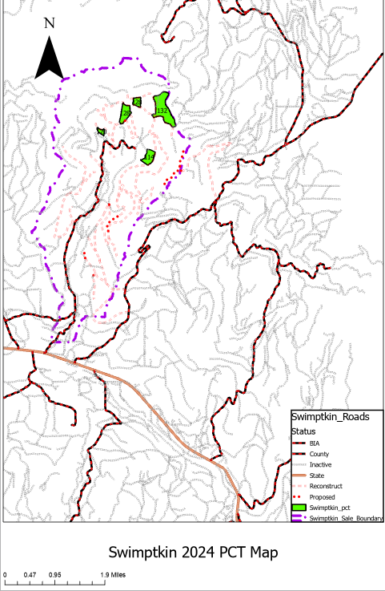

Unit Activity Table Swimptkin – Harvest Blocks
Block | Acres |  |  | Treatment |  | System |  | Slash Disposal |  | Site Prep | Whole Tree |  | PCT | PLANT
156-003 | 71.8 |  |  | IC |  | T |  |  | LOP/SCAT |  | YES
156-004 | 19.7 |  |  | SANI |  | T |  |  | LOP/SCAT |  | YES |  | YES
156-006 | 62.3 |  |  | SANI |  | T |  |  | LOP/SCAT |  | YES |  | EVAL DMT
148-007 | 61.0 |  |  | IC |  | T |  |  | LOP/SCAT |  | YES
156-008 | 72.0 |  |  | SW |  | T |  |  | LOP/SCAT | TOO STEEP FOR EX/P | YES
156-009 | 47.6 |  |  | ST |  | TETH |  |  |  |  | YES
156-010 | 18.4 |  |  | ST/OR |  | T |  |  | LOP/SCAT |  | YES |  | EVAL
148-012 | 10.1 |  |  | ST |  | TETH |  |  |  | Rx BURN | YES
156-014 | 53.3 |  |  | IC |  | T |  |  | LOP/SCAT |  | YES
148-015 | 72.9 |  |  | ST/OR |  | T |  |  | LOP/SCAT |  | YES |  | EVAL
156-016 | 99.0 |  |  | ST |  | TETH |  |  | LOP/SCAT |  | YES
148-017 | 17.6 |  |  | RRT |  | TETH |  |  |  | RX BURN | YES |  |  | YES
156-018 | 33.4 |  |  | RRT |  | T |  |  | BURN | EX/P | YES |  |  | YES
156-020 | 100.3 |  |  | SANI |  | TETH |  |  |  | Rx BURN | YES
156-023 | 21.4 |  |  | SANI |  | T |  |  | BURN | EX/P | YES |  |  | EVAL
156-027 | 43.4 |  |  | RRT |  | TETH- DUE TO CROSSING |  |  | BURN | EX/P | YES |  |  | YES
156-028 | 80.0 |  |  | IC |  | T |  |  |  |  | YES
156-030 | 47.9 |  |  | IC |  | T |  |  | LOP/SCAT |  | YES
156-032 | 72.4 |  |  | IC |  | T |  |  | LOP/SCAT |  | YES
156-034 | 54.8 |  |  | IC |  | T |  |  | LOP/SCAT |  | YES
156-058 | 20.0 |  |  | SANI |  | T |  |  | LOP/SCAT |  | YES
148-119 | 114.9 |  |  | OR |  | T |  |  |  |  | YES |  | YES
148-222 | 25.7 |  |  | ST/OR |  | T |  |  | LOP/SCAT |  | YES
148-230 | 101.9 |  |  | ST |  | T |  |  | BURN | EX/P | YES
148-2493-B | 27.3 |  |  | ST/OR |  | T |  |  | BURN | EX/P | YES
148-253 | 62.9 |  |  | ST |  | T |  |  | BURN | EX/P | YES
156-365 | 95.4 |  |  | ST/OR |  | T |  |  | LOP/SCAT |  | YES
148-794 | 13.6 |  |  |  |  | T |  |  | Burn | EX/P | YES
Swimptkin Pre-Commercial Thinning Blocks -PCT
COMP |  | BLOCK |  |  |  |  | ACRES |  |  | RX
156 |  | 114 |  |  |  |  | 28.5 |  |  | PCT
156 |  | 128 |  |  |  |  | 14.3 |  |  | PCT
156 |  | 132 |  |  |  |  | 89.3 |  |  | PCT
156 |  | 120 |  |  |  |  | 7.4 |  |  | PCT
156 |  | 128 |  |  |  |  | 32.1 |  |  | PCT
 |  | TOTAL |  |  |  |  | 171.6
7.2 Appendix B: Consultation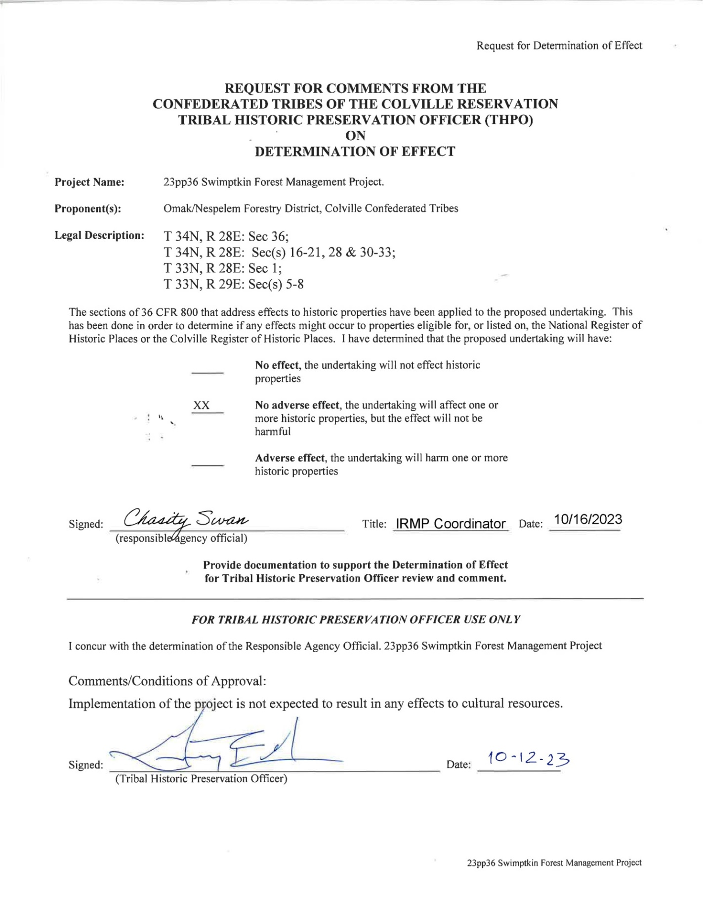

United States Department of the Interior
FISH AND WILDLIFE SERVICE
Washington Fish And Wildlife Office 510 Desmond Drive Se, Suite 102
Lacey, WA 98503-1263
Phone: (360) 753-9440 Fax: (360) 753-9405

In Reply Refer To:
Project Code: 2024-0037439
Project Name: Swimptkin Forestry Sale 2024-2025

Subject: List of threatened and endangered species that may occur in your proposed project location or may be affected by your proposed project
To Whom It May Concern:
The enclosed species list identifies threatened, endangered, proposed and candidate species, as well as proposed and final designated critical habitat, that may occur within the boundary of your proposed project and/or may be affected by your proposed project. The species list fulfills the requirements of the U.S. Fish and Wildlife Service (Service) under section 7(c) of the Endangered Species Act (Act) of 1973, as amended (16 U.S.C. 1531 et seq.).
New information based on updated surveys, changes in the abundance and distribution of species, changed habitat conditions, or other factors could change this list. Please feel free to contact us if you need more current information or assistance regarding the potential impacts to federally proposed, listed, and candidate species and federally designated and proposed critical habitat. Please note that under 50 CFR 402.12(e) of the regulations implementing section 7 of the Act, the accuracy of this species list should be verified after 90 days. This verification can be completed formally or informally as desired. The Service recommends that verification be completed by visiting the IPaC website at regular intervals during project planning and implementation for updates to species lists and information. An updated list may be requested through the IPaC system by completing the same process used to receive the enclosed list.
The purpose of the Act is to provide a means whereby threatened and endangered species and the ecosystems upon which they depend may be conserved. Under sections 7(a)(1) and 7(a)(2) of the Act and its implementing regulations (50 CFR 402 et seq.), Federal agencies are required to utilize their authorities to carry out programs for the conservation of threatened and endangered species and to determine whether projects may affect threatened and endangered species and/or designated critical habitat.
A Biological Assessment is required for construction projects (or other undertakings having similar physical impacts) that are major Federal actions significantly affecting the quality of the human environment as defined in the National Environmental Policy Act (42 U.S.C. 4332(2) (c)). For projects other than major construction activities, the Service suggests that a biological evaluation similar to a Biological Assessment be prepared to determine whether the project may affect listed or proposed species and/or designated or proposed critical habitat. Recommended contents of a Biological Assessment are described at 50 CFR 402.12.
If a Federal agency determines, based on the Biological Assessment or biological evaluation, that listed species and/or designated critical habitat may be affected by the proposed project, the agency is required to consult with the Service pursuant to 50 CFR 402. In addition, the Service recommends that candidate species, proposed species and proposed critical habitat be addressed within the consultation. More information on the regulations and procedures for section 7 consultation, including the role of permit or license applicants, can be found in the "Endangered Species Consultation Handbook" at:
https://www.fws.gov/sites/default/files/documents/endangered-species-consultation- handbook.pdf
Migratory Birds: In addition to responsibilities to protect threatened and endangered species under the Endangered Species Act (ESA), there are additional responsibilities under the Migratory Bird Treaty Act (MBTA) and the Bald and Golden Eagle Protection Act (BGEPA) to protect native birds from project-related impacts. Any activity, intentional or unintentional, resulting in take of migratory birds, including eagles, is prohibited unless otherwise permitted by the U.S. Fish and Wildlife Service (50 C.F.R. Sec. 10.12 and 16 U.S.C. Sec. 668(a)). For more information regarding these Acts, see https://www.fws.gov/program/migratory-bird-permit/what- we-do.
The MBTA has no provision for allowing take of migratory birds that may be unintentionally killed or injured by otherwise lawful activities. It is the responsibility of the project proponent to comply with these Acts by identifying potential impacts to migratory birds and eagles within applicable NEPA documents (when there is a federal nexus) or a Bird/Eagle Conservation Plan (when there is no federal nexus). Proponents should implement conservation measures to avoid or minimize the production of project-related stressors or minimize the exposure of birds and their resources to the project-related stressors. For more information on avian stressors and recommended conservation measures, see https://www.fws.gov/library/collections/threats-birds.
In addition to MBTA and BGEPA, Executive Order 13186: Responsibilities of Federal Agencies to Protect Migratory Birds, obligates all Federal agencies that engage in or authorize activities that might affect migratory birds, to minimize those effects and encourage conservation measures that will improve bird populations. Executive Order 13186 provides for the protection of both migratory birds and migratory bird habitat. For information regarding the implementation of Executive Order 13186, please visit https://www.fws.gov/partner/council-conservation- migratory-birds.
We appreciate your concern for threatened and endangered species. The Service encourages Federal agencies to include conservation of threatened and endangered species into their project planning to further the purposes of the Act. Please include the Consultation Code in the header of
this letter with any request for consultation or correspondence about your project that you submit to our office.
Attachment(s):
- Official Species List
OFFICIAL SPECIES LIST
This list is provided pursuant to Section 7 of the Endangered Species Act, and fulfills the requirement for Federal agencies to "request of the Secretary of the Interior information whether any species which is listed or proposed to be listed may be present in the area of a proposed action".
This species list is provided by:
Washington Fish And Wildlife Office
510 Desmond Drive Se, Suite 102
Lacey, WA 98503-1263
(360) 753-9440
PROJECT SUMMARY
Project Code: 2024-0037439
Project Name: Swimptkin Forestry Sale 2024-2025 Project Type: Forest Management Plan
Project Description: Swimptkin Forestry Sale is Located in Okanogan Co. on the Colville Tribe Reservation.
Project Location:
The approximate location of the project can be viewed in Google Maps: https:// www.google.com/maps/@48.403660599999995,-119.21273625042774,14z
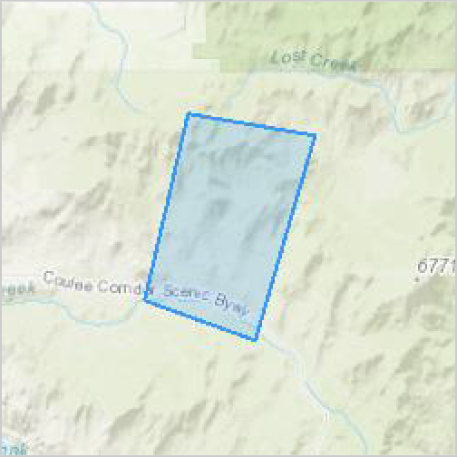
Counties: Okanogan County, Washington

ENDANGERED SPECIES ACT SPECIES
There is a total of 6 threatened, endangered, or candidate species on this species list.
Species on this list should be considered in an effects analysis for your project and could include species that exist in another geographic area. For example, certain fish may appear on the species list because a project could affect downstream species.
IPaC does not display listed species or critical habitats under the sole jurisdiction of NOAA Fisheries¹, as USFWS does not have the authority to speak on behalf of NOAA and the Department of Commerce.
See the "Critical habitats" section below for those critical habitats that lie wholly or partially within your project area under this office's jurisdiction. Please contact the designated FWS office if you have questions.

1. NOAA Fisheries, also known as the National Marine Fisheries Service (NMFS), is an office of the National Oceanic and Atmospheric Administration within the Department of Commerce.

MAMMALS
NAME STATUS

Canada Lynx Lynx canadensis
Population: Wherever Found in Contiguous U.S.
There is final critical habitat for this species. Your location does not overlap the critical habitat. Species profile: https://ecos.fws.gov/ecp/species/3652
North American Wolverine Gulo gulo luscus No critical habitat has been designated for this species. Species profile: https://ecos.fws.gov/ecp/species/5123
Threatened

Threatened

BIRDS
NAME STATUS

Yellow-billed Cuckoo Coccyzus americanus
Population: Western U.S. DPS
There is final critical habitat for this species. Your location does not overlap the critical habitat. Species profile: https://ecos.fws.gov/ecp/species/3911
Threatened

FISHES
NAME STATUS

Bull Trout Salvelinus confluentus
Population: U.S.A., coterminous, lower 48 states
There is final critical habitat for this species. Your location does not overlap the critical habitat.
Threatened

INSECTS
NAME STATUS

Monarch Butterfly Danaus plexippus
No critical habitat has been designated for this species. Species profile: https://ecos.fws.gov/ecp/species/9743
Candidate

CONIFERS AND CYCADS
NAME STATUS

Whitebark Pine Pinus albicaulis

No critical habitat has been designated for this species. Species profile: https://ecos.fws.gov/ecp/species/1748

CRITICAL HABITATS
THERE ARE NO CRITICAL HABITATS WITHIN YOUR PROJECT AREA UNDER THIS OFFICE'S JURISDICTION.
YOU ARE STILL REQUIRED TO DETERMINE IF YOUR PROJECT(S) MAY HAVE EFFECTS ON ALL ABOVE LISTED SPECIES.

IPAC USER CONTACT INFORMATION
Agency: Confederated Tribes of the Colville Reservation Name: Marcus McClung
Address: 21 Colville St. City: nespelem
State: WA
Zip: 99155
Email marcus.mcclung.fnw@colvilletribes.com Phone: 5096340093

7.3 Appendix C: Preliminary Transportation Analysis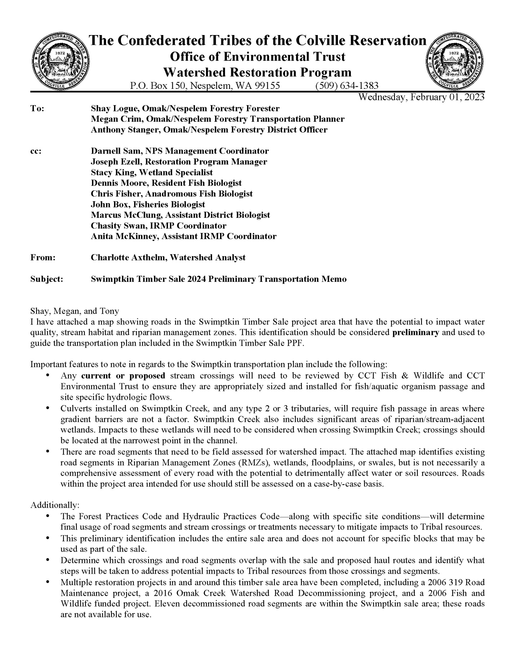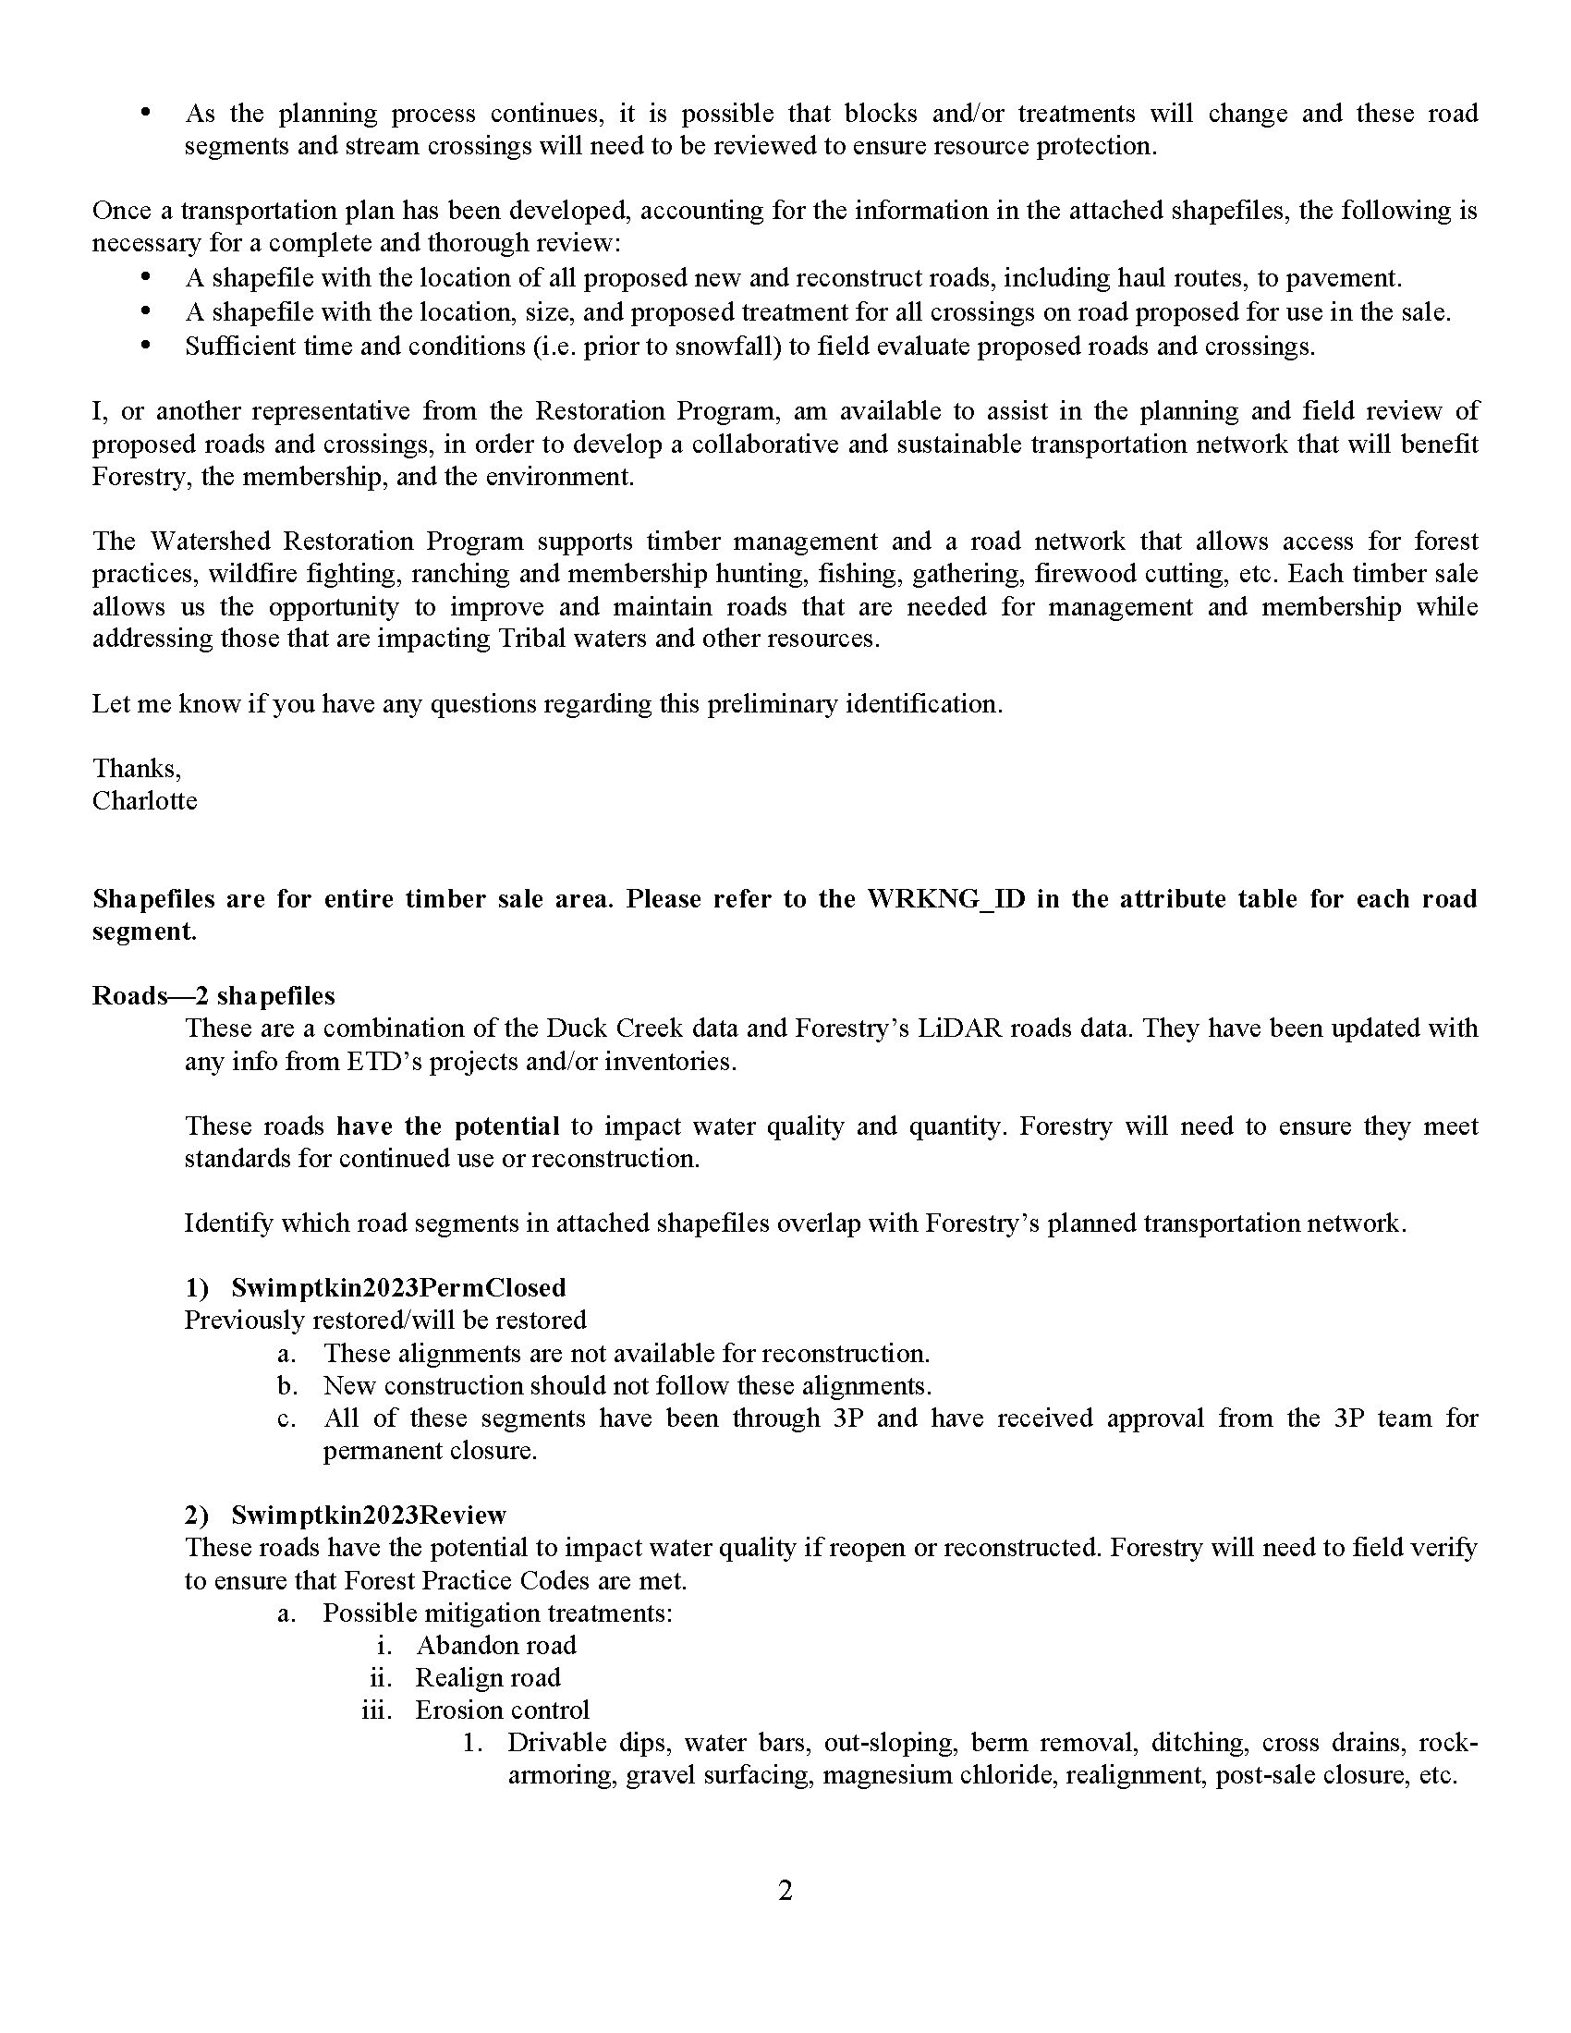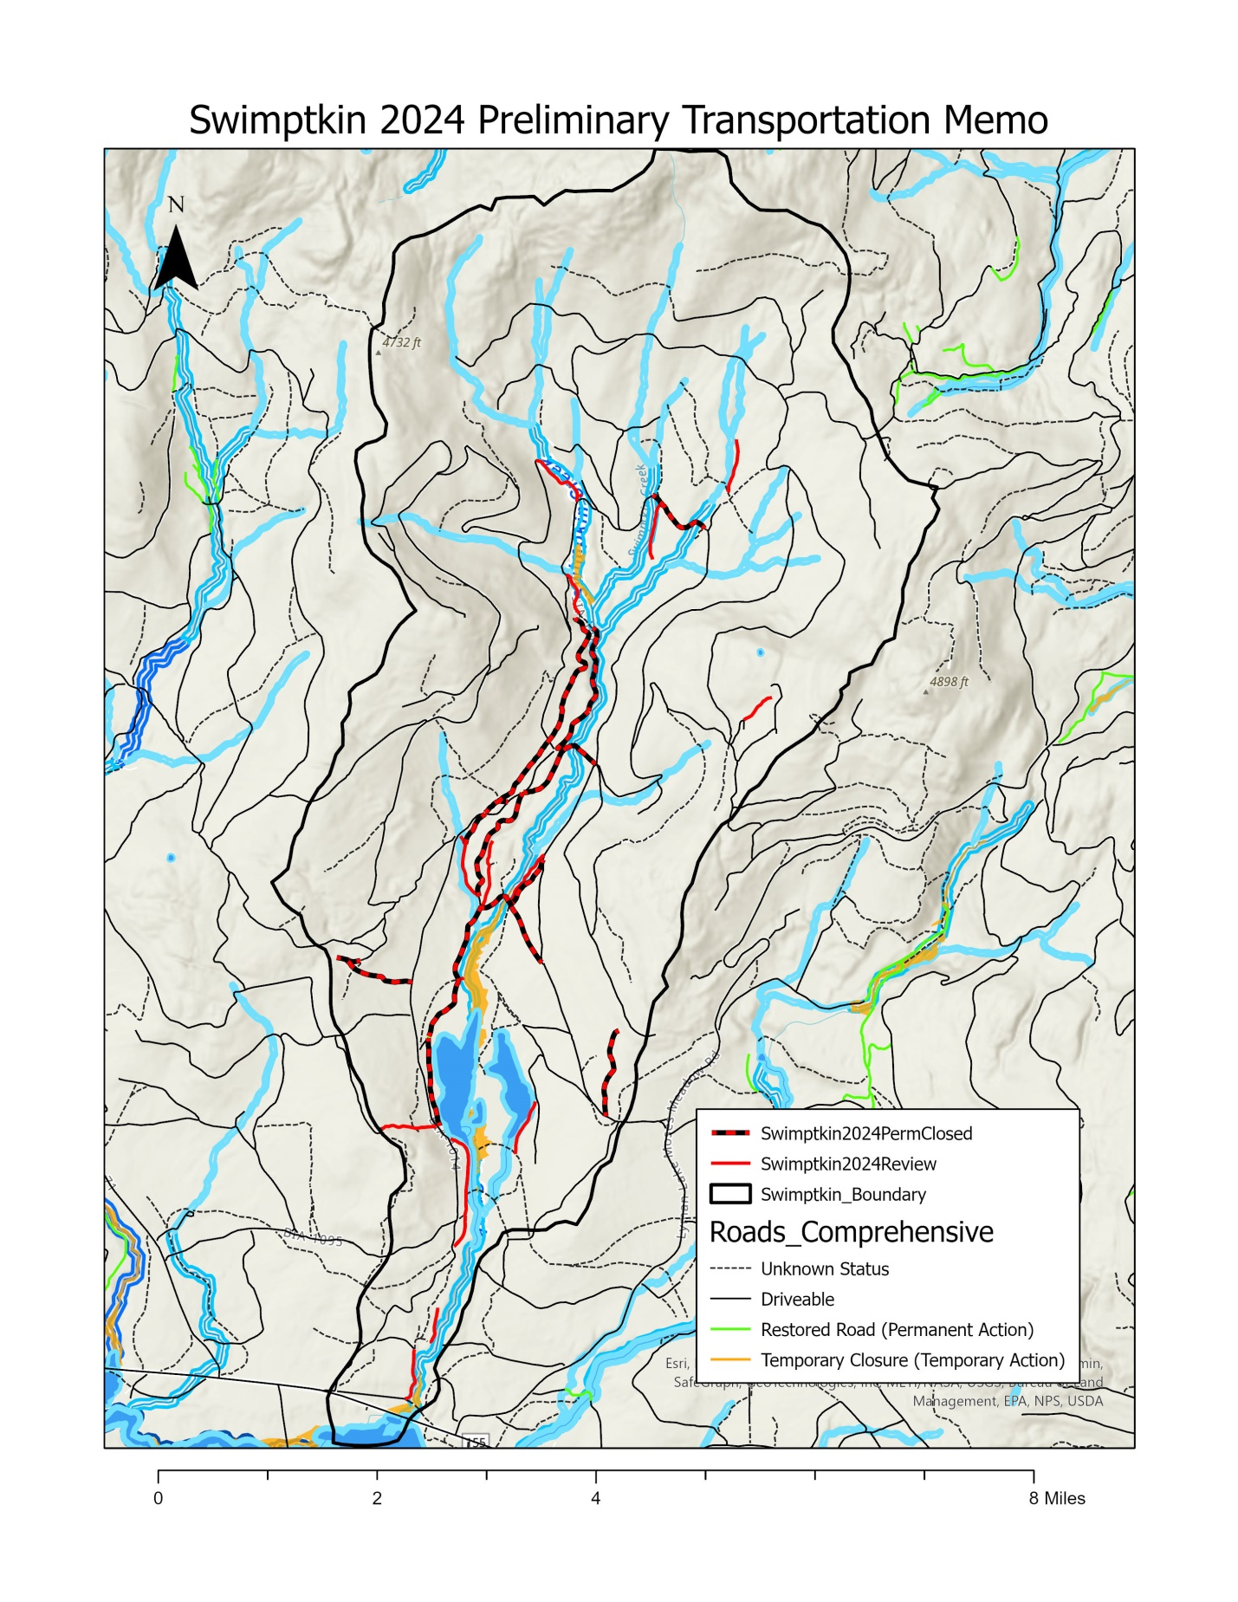
1
7.4 Appendix D: Army Corp of Engineers BMPs
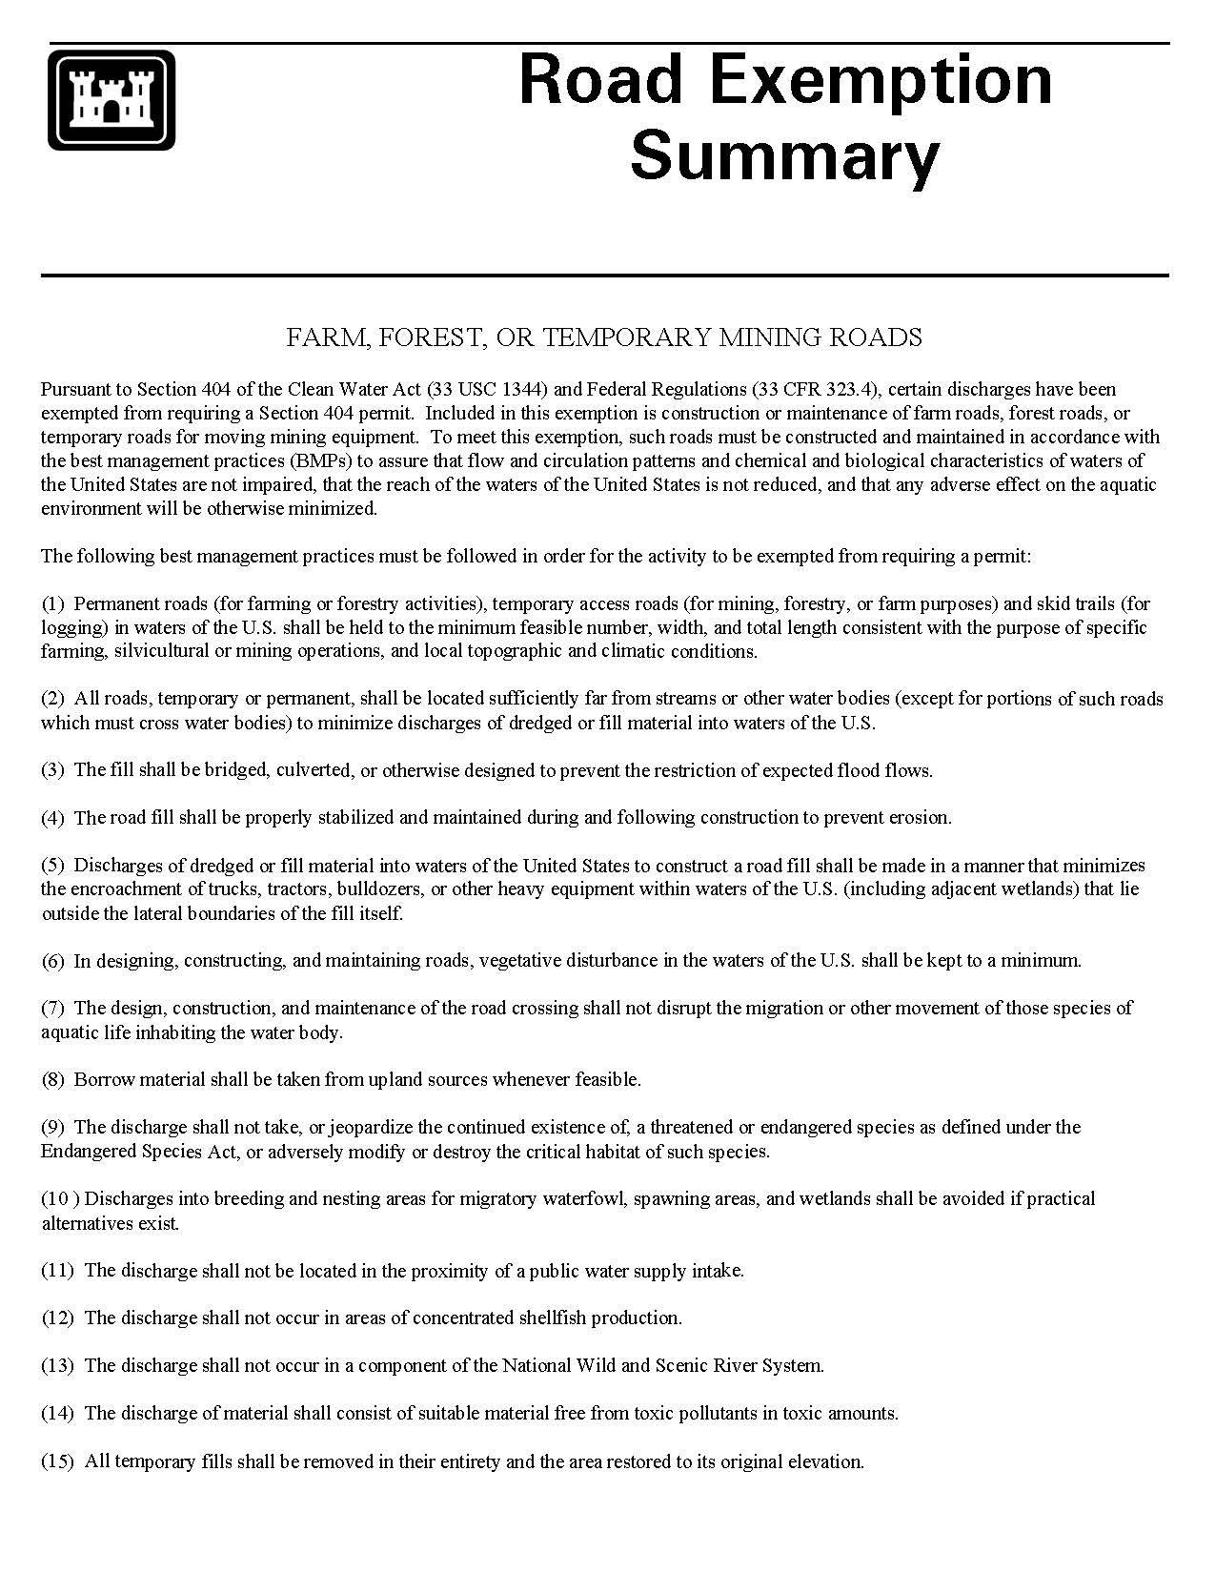
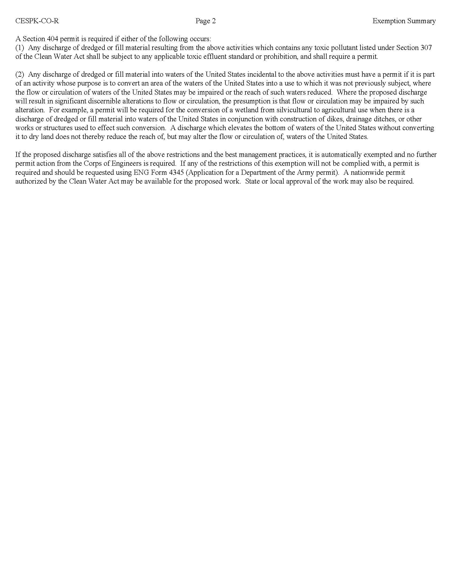

7.5 Appendix E: Fish and Wildlife Proposed Wildlife Buffers and Road Closures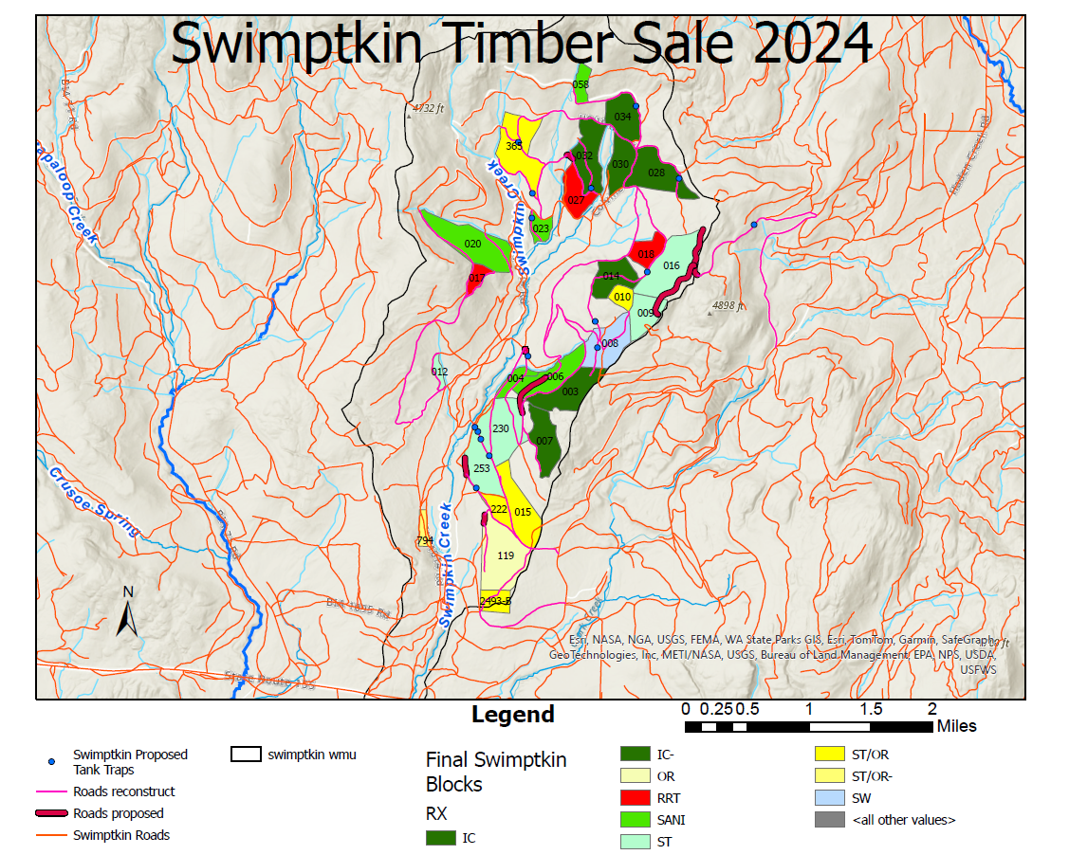

7.6 Appendix F: CTCR Holistic Goal and Desired Future Conditions
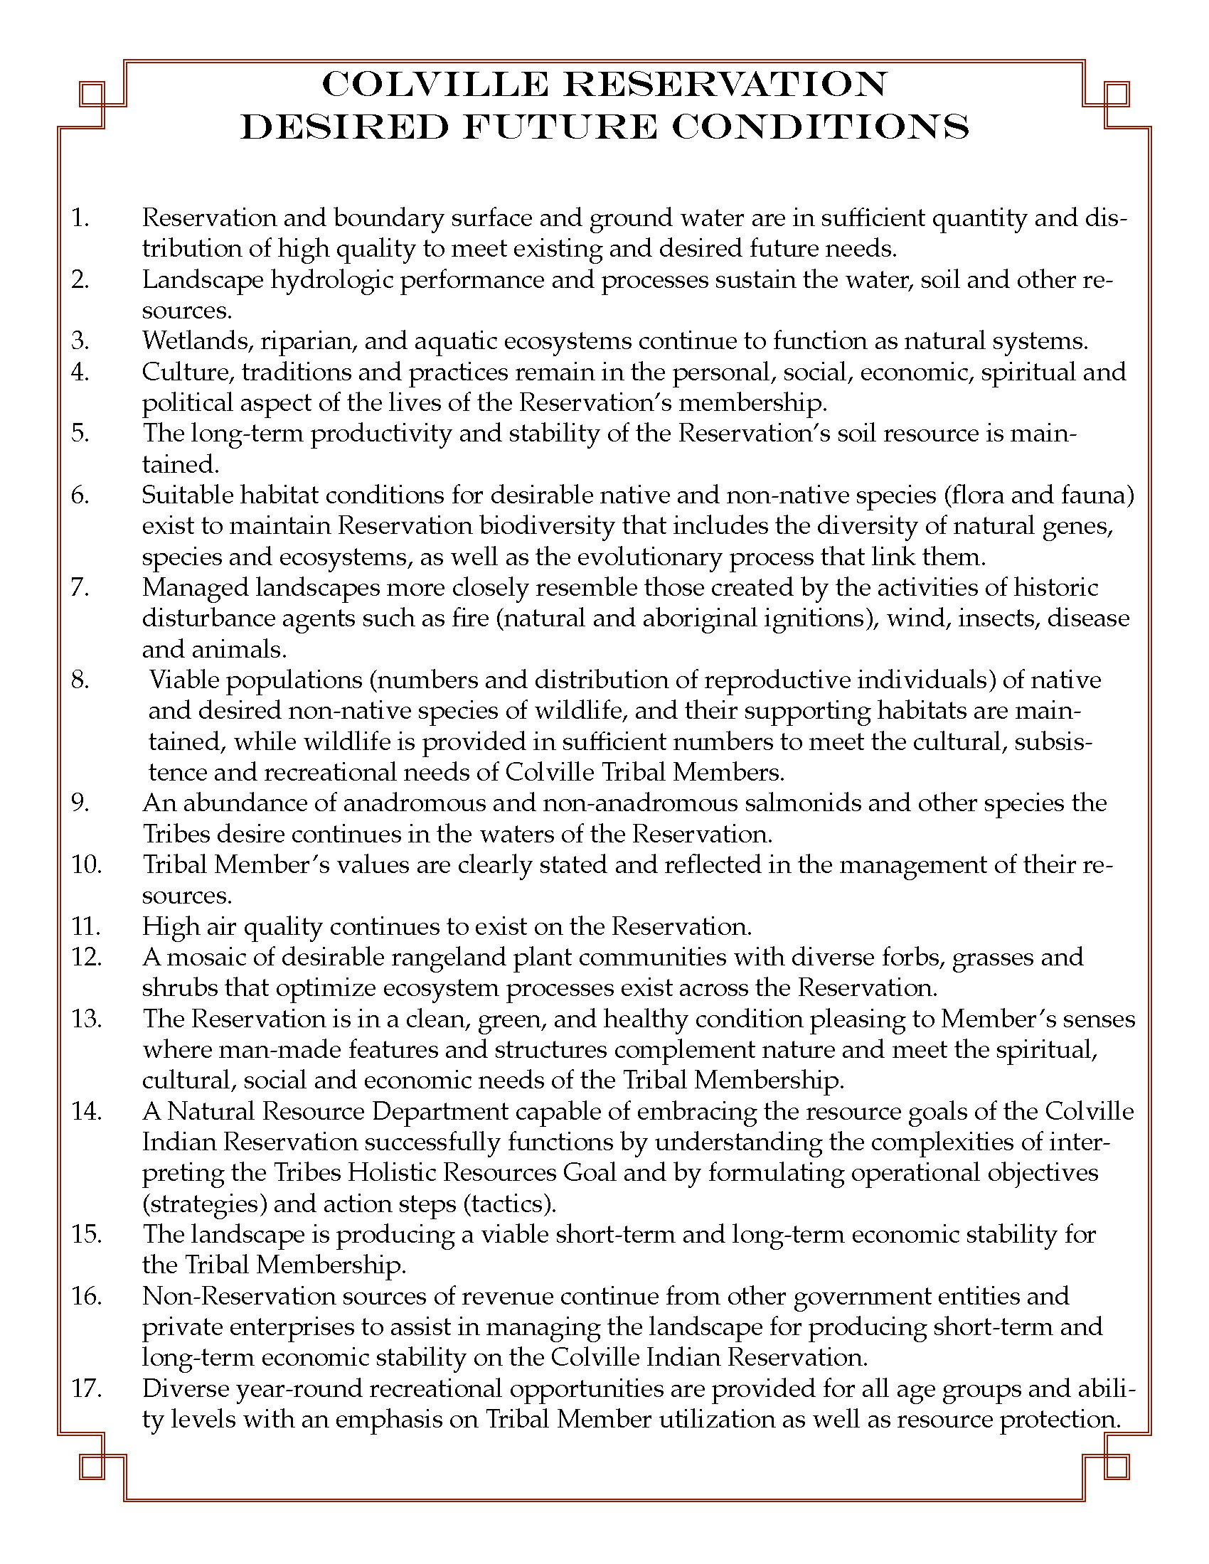

7.6 Appendix G: Fire Regimes and Condition Class
Fire regimes are used to categorize the historic frequency of fire on the landscape. The project area is primarily composed of three fire regimes:
Fire Regime I
Fires occurred frequently usually within a 0-35 year interval and were usually low severity, low intensity surface fires. Large stand replacing fire could occur under certain weather conditions, but were rare events (i.e. every 200+ years). Typical climax plant communities include ponderosa pine, eastside/dry Douglas fir and very dry white fir.
Fire Regime II
Fire Regime II had a historical fire return interval of 0-35 years and consisted mainly of mixed and high severity fires. This fire regime is generally found below, or as small inclusions within fire regime I, usually related to topographic changes and located mostly in deep canyons on south and west aspects. Fire return intervals and fire size are similar to those found in fire regime I. A few conifer trees may exist in isolated micro-sites sufficient to support limited forest community development. Canopy closure is generally less than 10% where trees exist.
Fire Regime III
Fires usually occurred on the landscape within a 35-100 year interval. This regime usually results in heterogeneous landscapes. Large high severity fires may occur but are usually rare events. Such high severity fires may reset large areas (10,000-100,000 acres) but subsequent mixed severity fires are important for creating the landscape heterogeneity. Within these landscapes a mix of stand ages and size classes are important characteristics; generally, the landscape is not dominated by one or two age classes.

Condition Class
Condition class is used to categorize the degree to which site conditions have departed from what would be considered their normal historic range. There are three condition class categories.
- Condition class 1 is defined as a fire regime that is within the normal historical fire return interval. The species composition, stand structure, stand age, canopy closure, and fire frequency has been slightly altered. Thus the risk of losing key ecosystem components from the occurrence of fire remains relatively low (USDA, DOI, 2000. National Fire Plan).
- Condition class 2 is defined as those sites that have been moderately altered from their historical fire regimes by either increased (human caused) or decreased (suppression) fire frequency and there is a moderate risk of losing key ecosystem components (USDA, DOI, 2000. National Fire Plan).
- Condition class 3 is defined as those sites that have been significantly altered from their historical fire regimes because the fire return intervals have been extensively altered, the risk of losing key ecosystem components from fire is high (USDA, DOI, 2000. National Fire Plan).
